User Manual

Sponsor: Dr. Matthias Stallmann

CSC 492 Team 43

Christina Albores

Vitesh Kambara

Julian Madrigal

Neha Ramesh

Minghong Zou

North Carolina State University

Department of Computer Science

04/22/2024

# Table of Contents:

Table of Contents:

Introduction

Application usage

Start the Web Application

Upload a Graph

Upload an Algorithm

Load a Graph/Algorithm Example

Running an Algorithm on a Loaded Graph

Exiting an Algorithm

Download a Graph/Algorithm

Adding Node Label and Weight

Editing Node Label and Weight

Adding Edge Label and Weight

Editing Edge Label and Weight

Editing a Graph in Edit Mode

Editing Graph text

Editing Algorithm Text

Keyboard Shortcuts

Preference Panel

Algorithm Methods

List Getters

Source and Target

Adjacencies

Marks

Highlights

Colors

Labels

Weights

Hide/Show Node Properties

Hide/Show Edge Properties

Node Shape

Node Border Width

Node Shading

Node Size

Edge Width

# 

# **Introduction**

Galant-JS is a web application that facilitates visualizing graph algorithms for research and classroom instruction. This is a manual on how to use the Galant-JS application.

# **Application usage**

## **Start the Web Application**

1. Navigate to the website<https://galant.csc.ncsu.edu/> in a compatible browser (Chrome/Firefox)

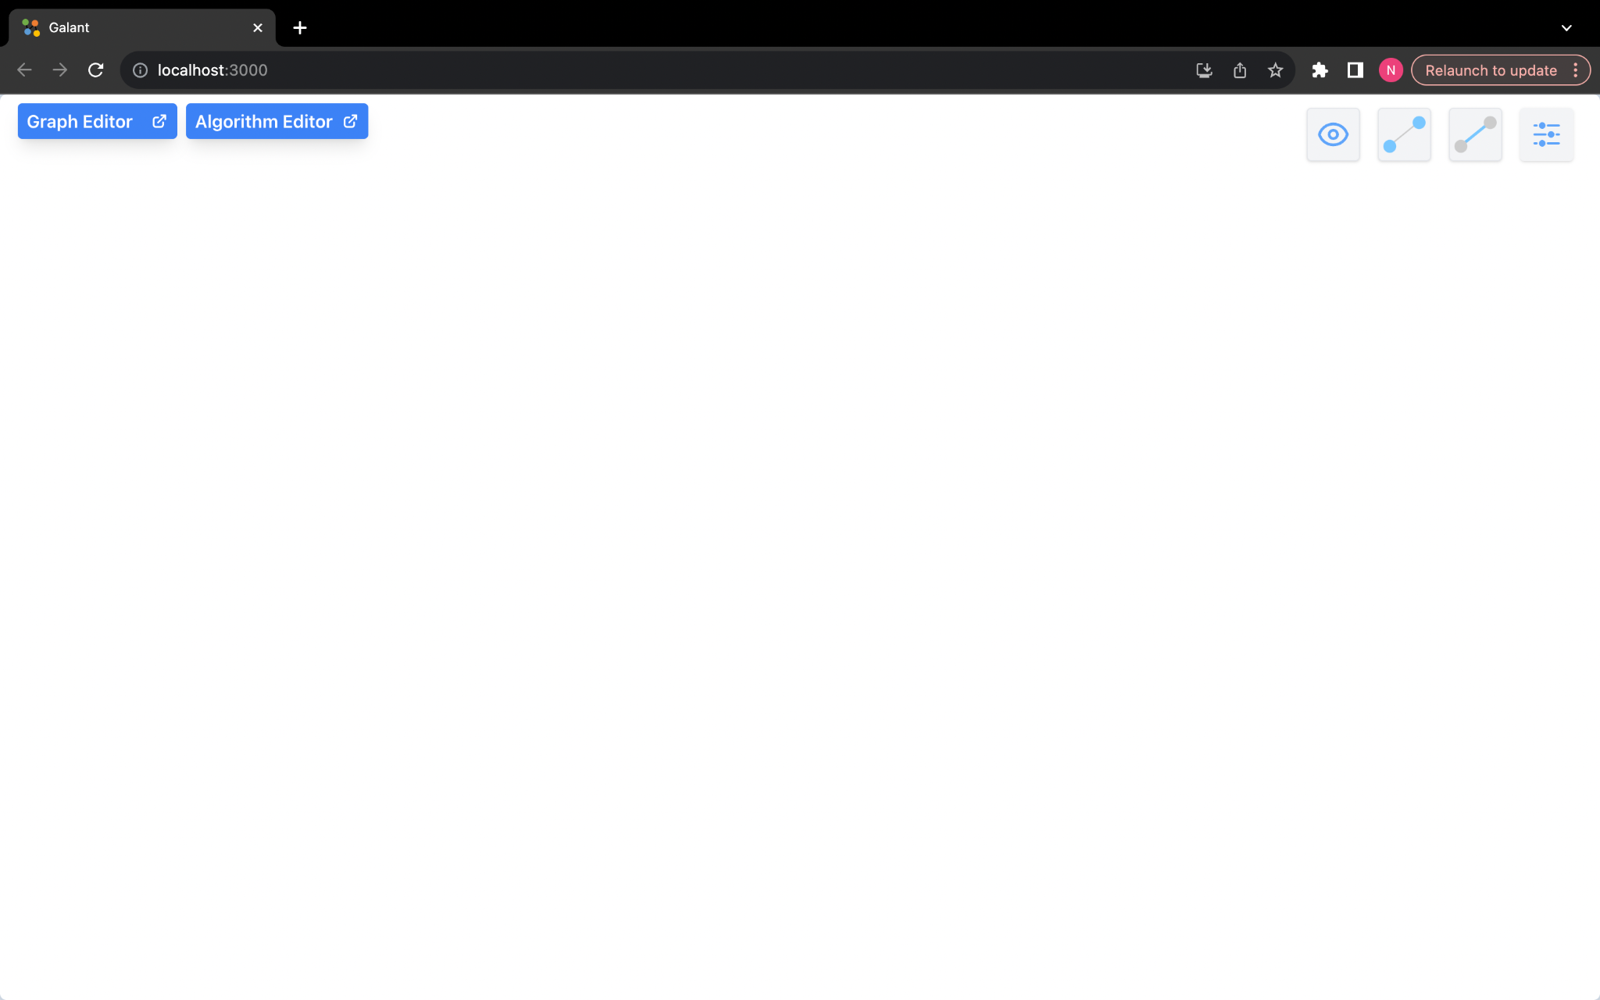

2. Remove any pop-up blockers that might be installed on the web browser.

## **Upload a Graph**

1. Load the application on a webpage

2. Click on the "Graph Editor" button on the menu bar

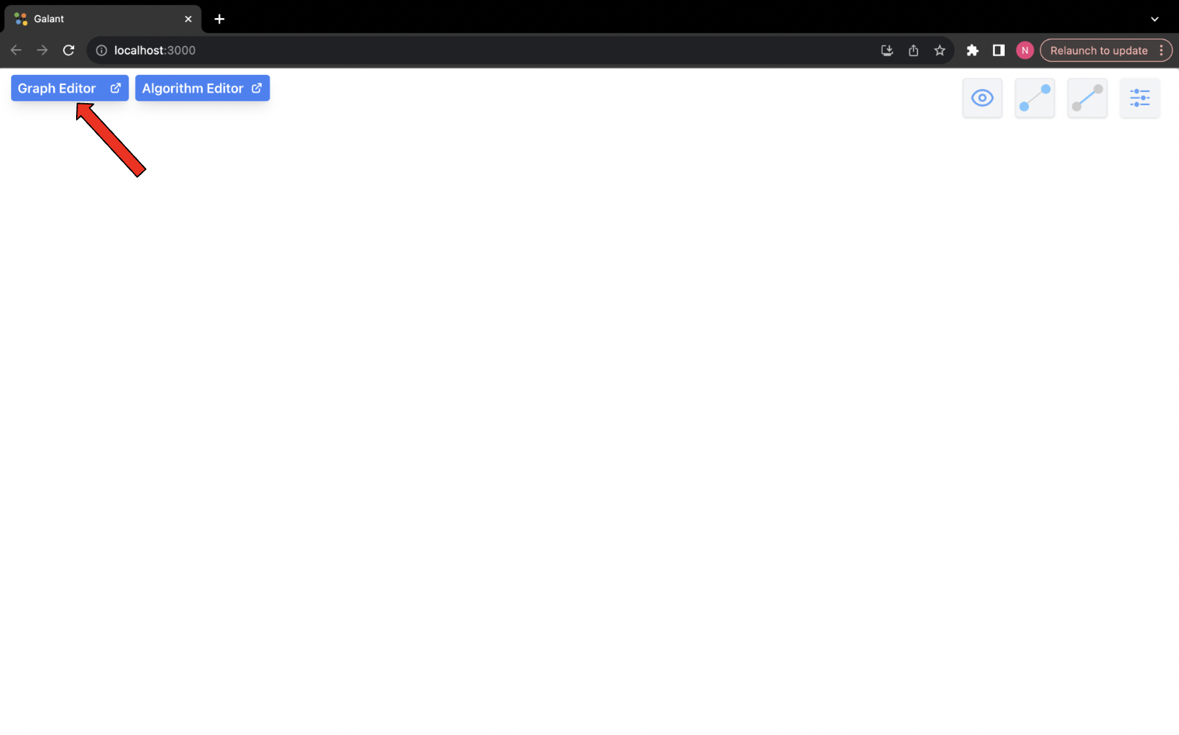

3. Click on the “Upload” button in the window that pops up. Choose the graph that you want to upload from the file explorer window.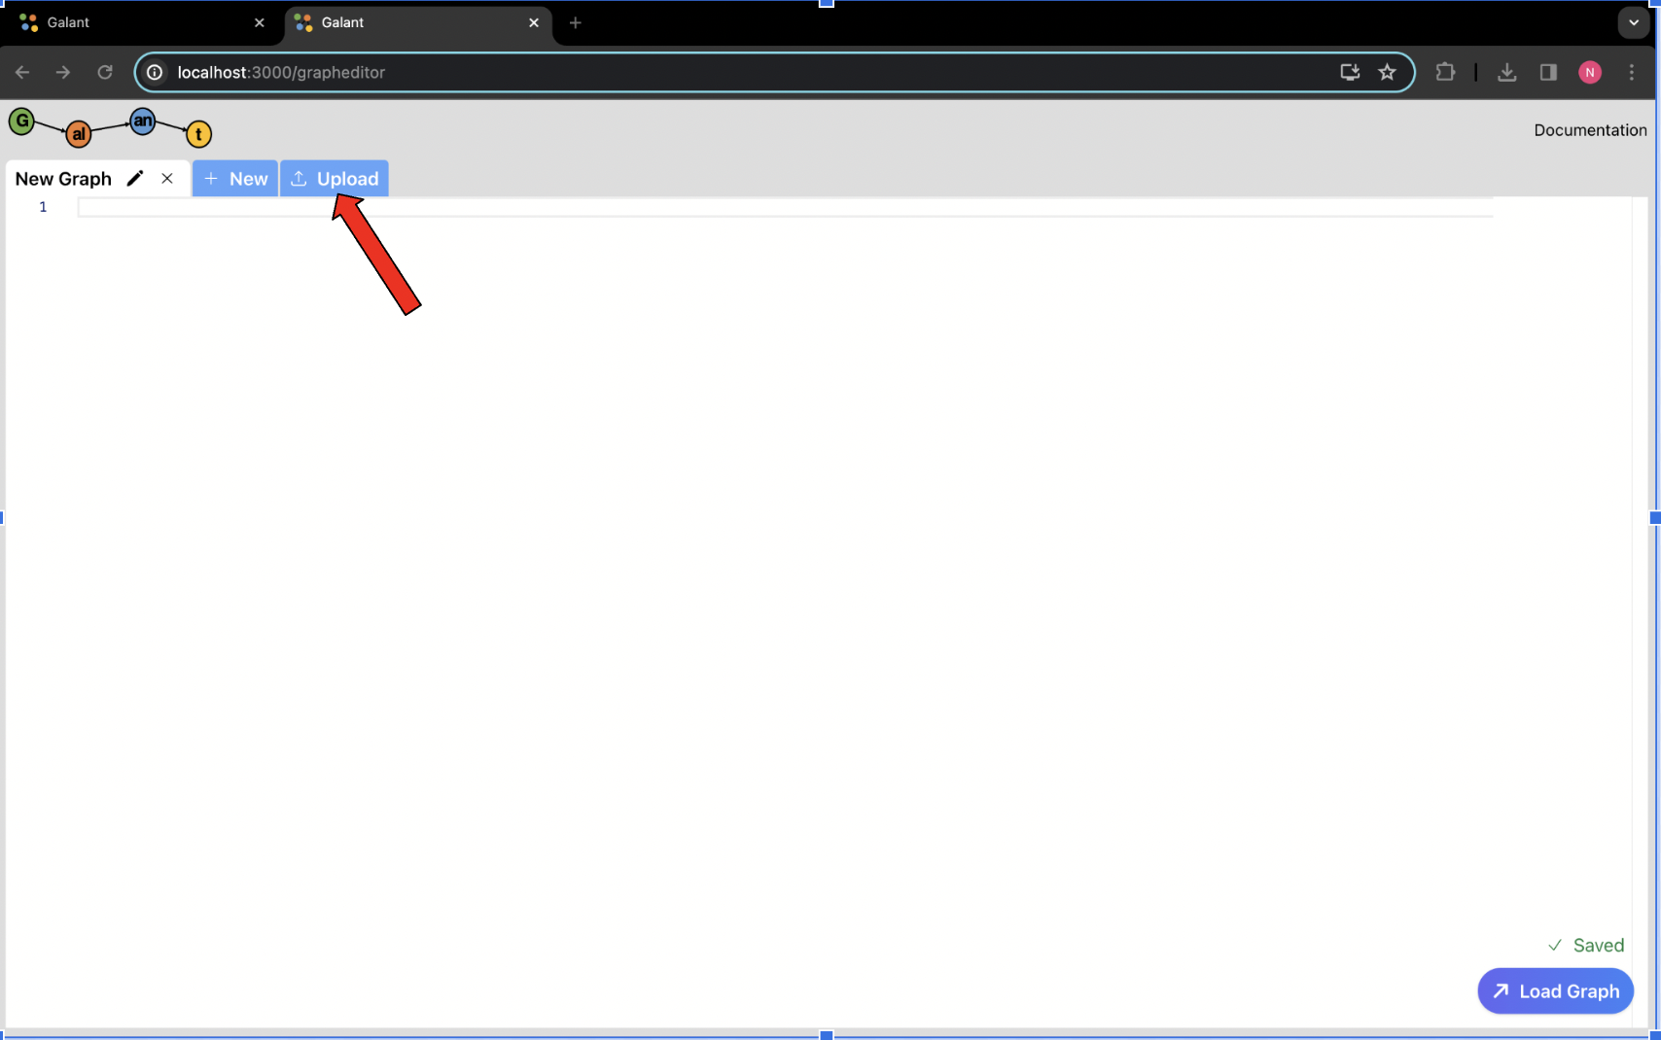

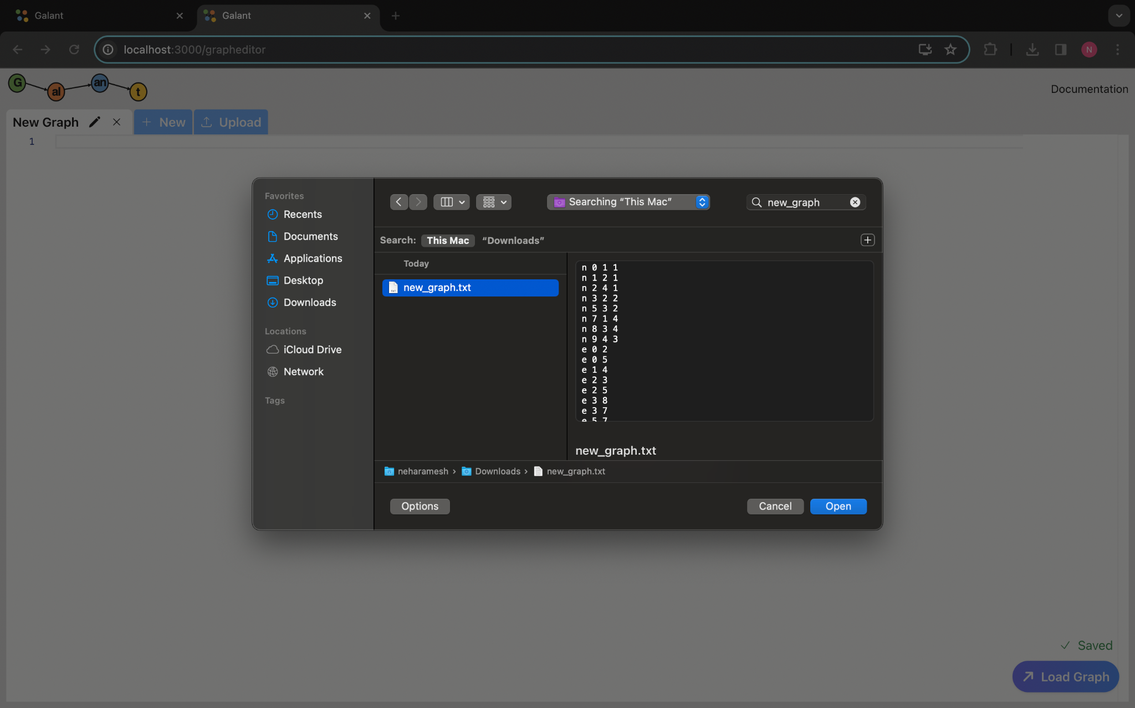

4. The uploaded graph should be loaded in a new tab with the graph name.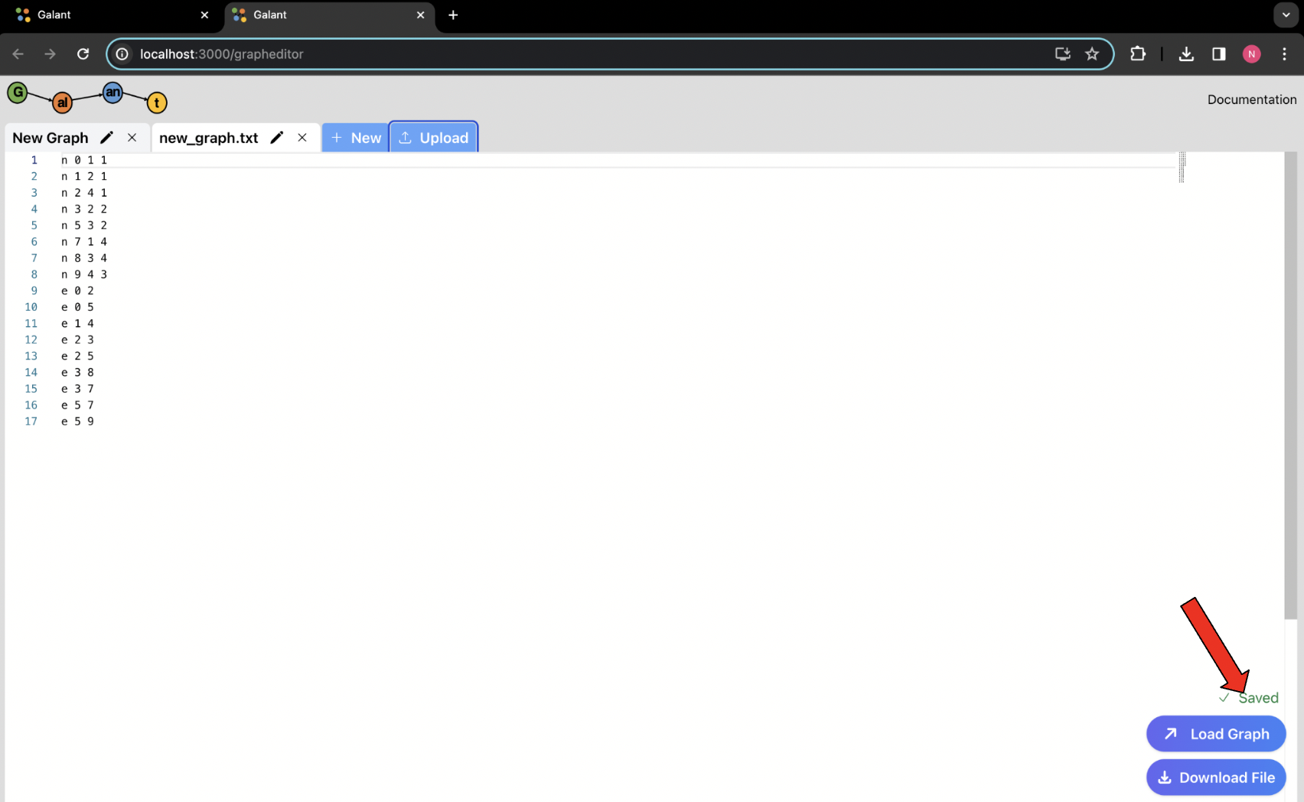

## 

## 

## 

## 

## 

## **Upload an Algorithm**

1. Load the application on a webpage

2. Click on the "Algorithm Editor" button on the main view page.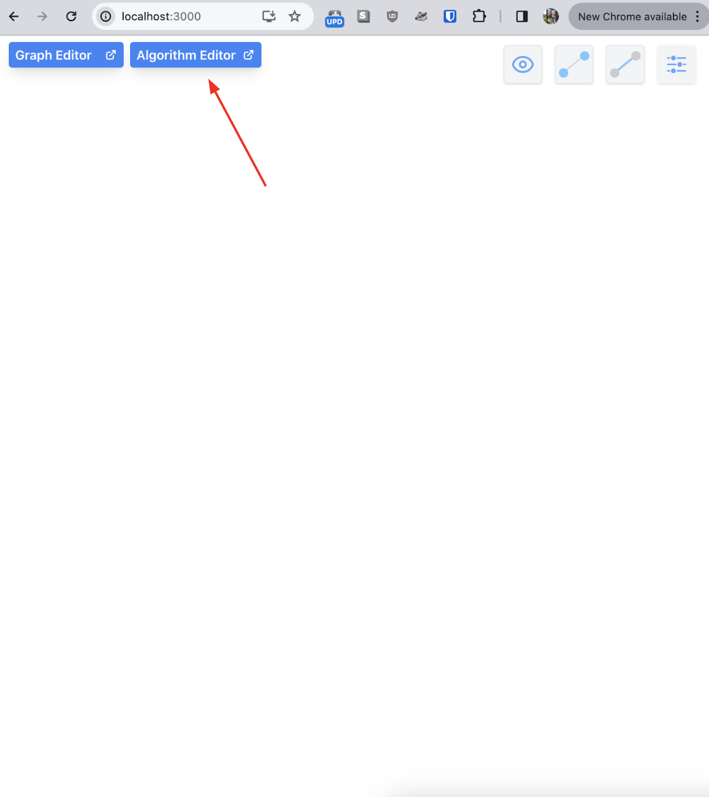

3. In the Algorithm Editor pop-up window, click on the “Upload Algorithm” button.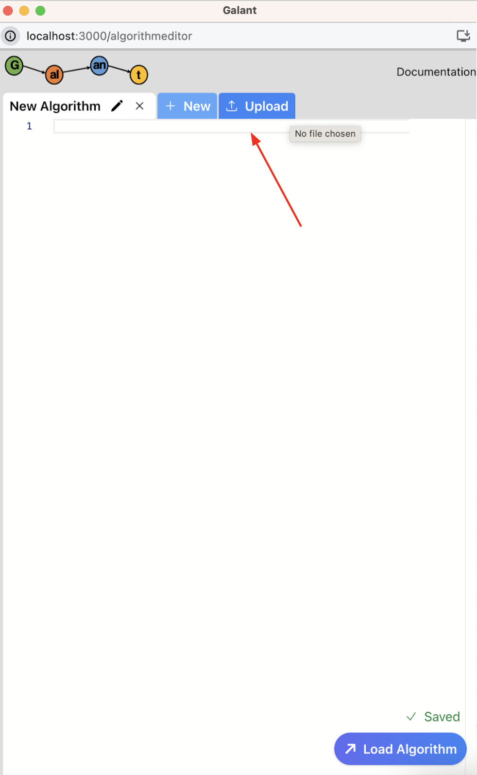

4. Choose the algorithm that you want to upload from the file explorer window.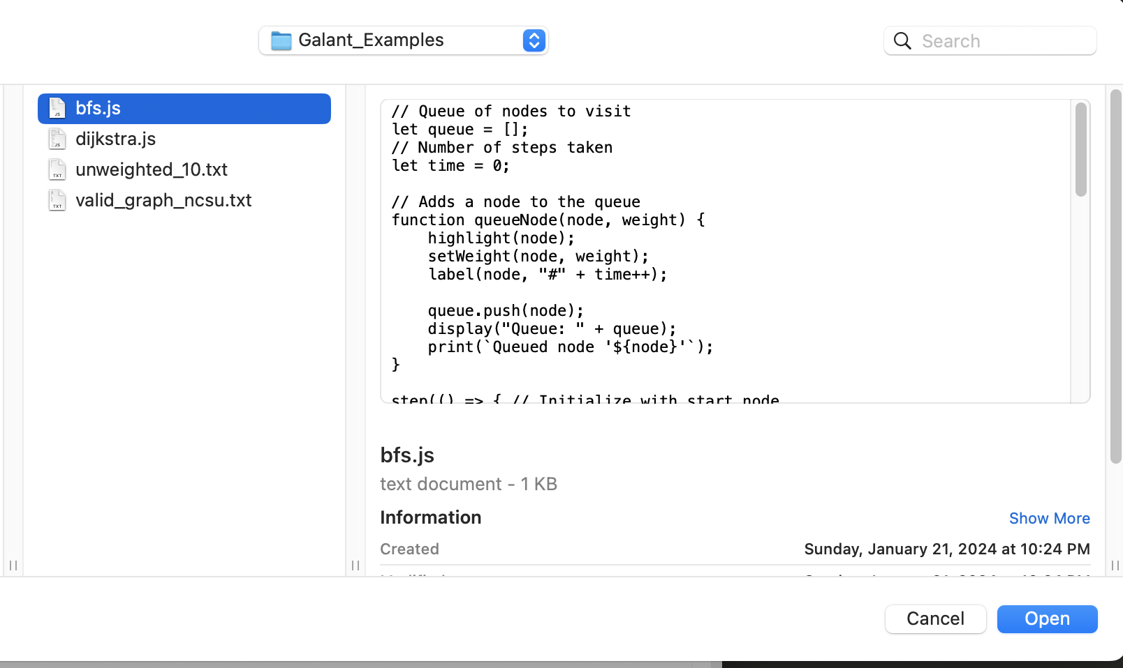

5. The algorithm editor should contain the text of your uploaded algorithm file. 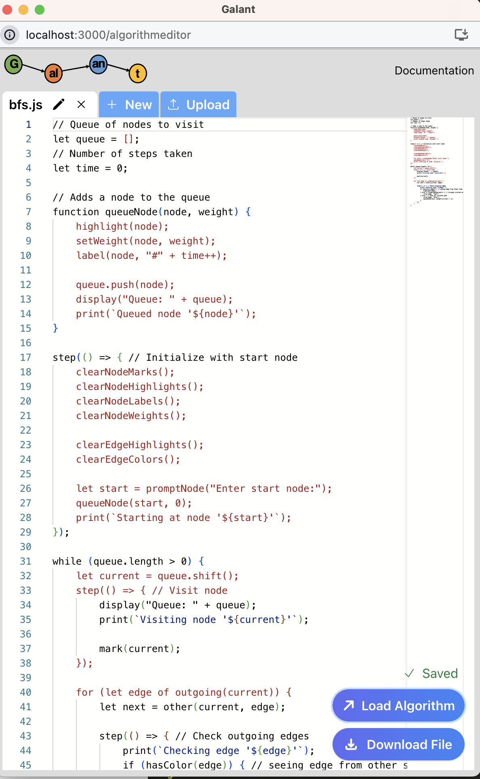

## **Load a Graph/Algorithm Example**

**Note**: The graph steps apply the same as the algorithm steps

1. Load the application on a webpage.

2. Click on the "Graph/Algorithm Editor" button on the main view page.

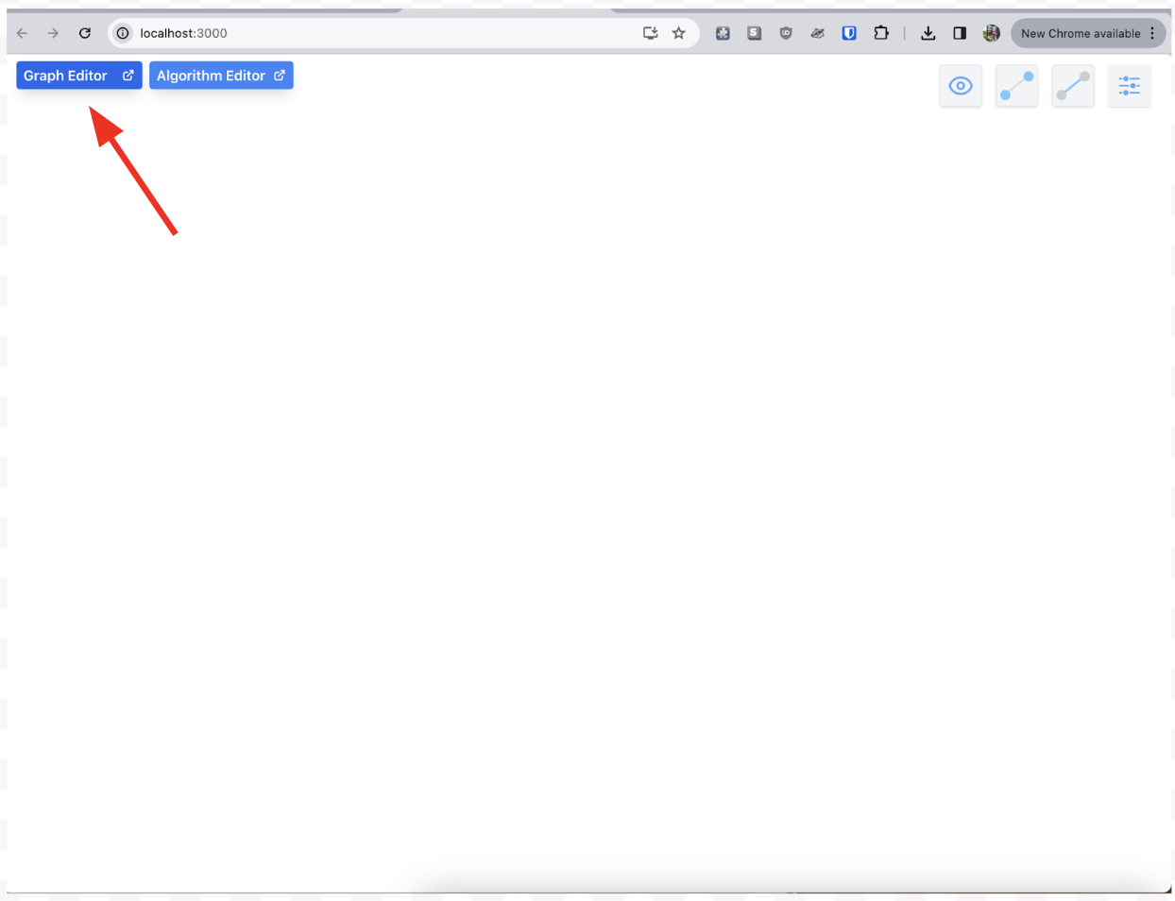

3. In the Graph/Algorithm Editor pop-up window, select the new button. 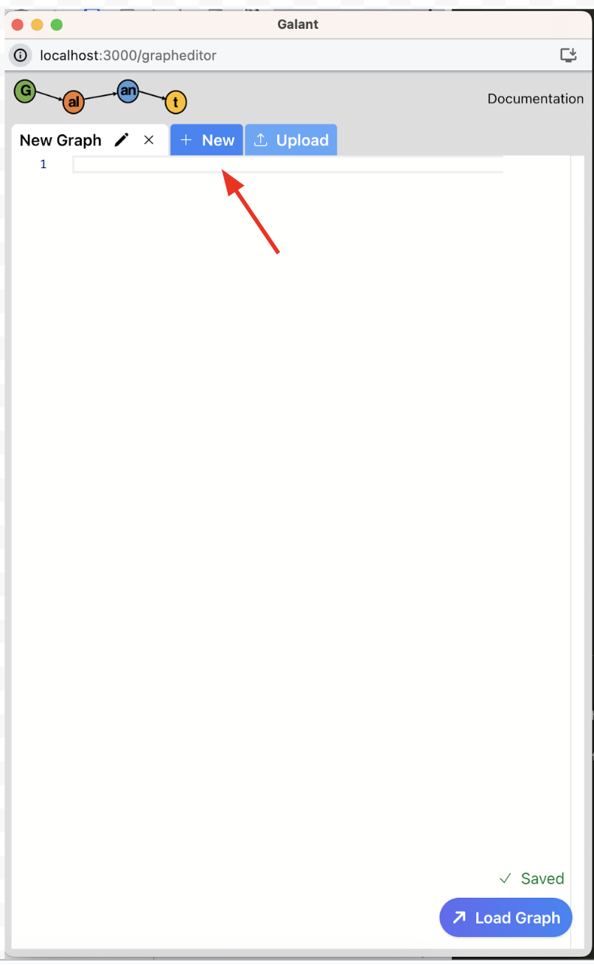

4. From the drop down select a graph/algorithm from the list of examples.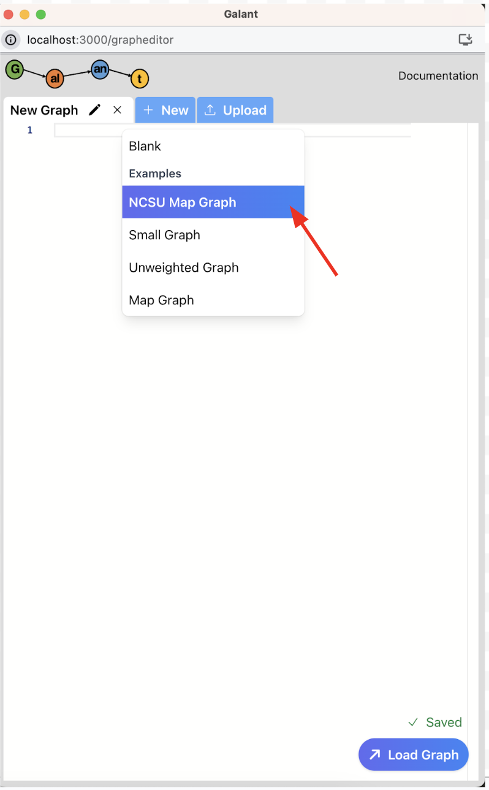

5. Click the "Load Graph/Algorithm" button, and if successful the graph view will be updated with the graph or the algorithm name at the bottom.

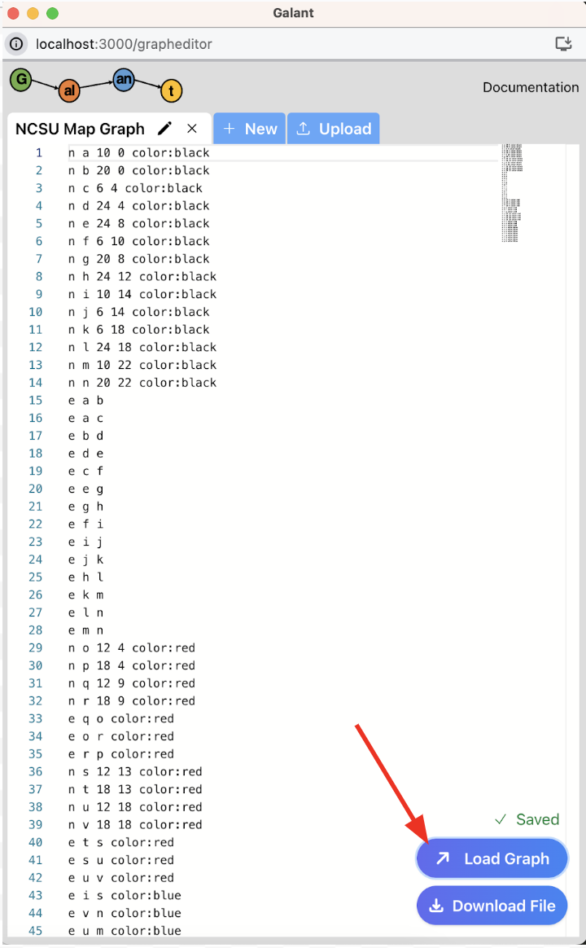

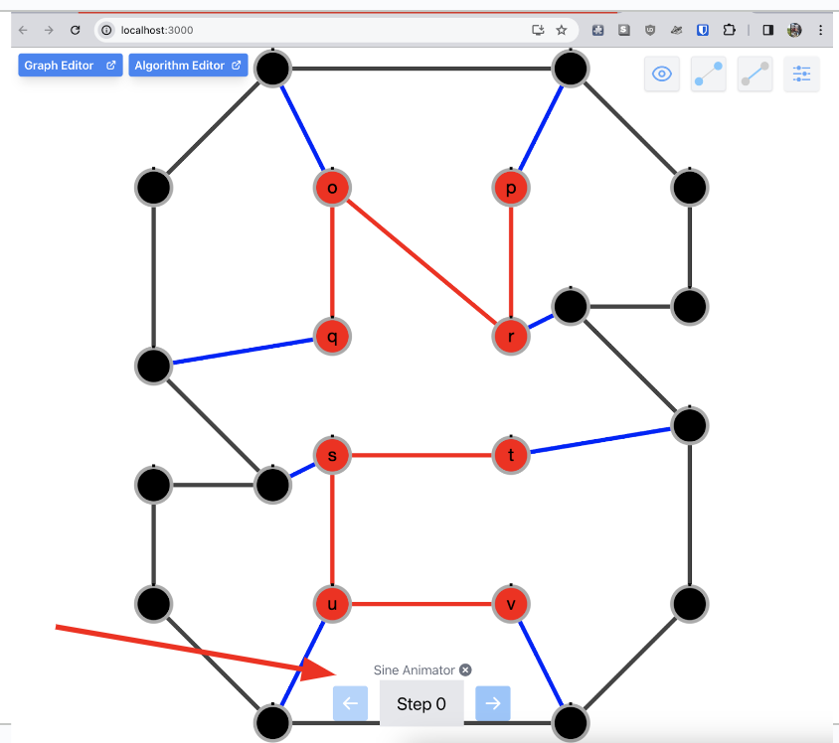

## 

## 

## **Running an Algorithm on a Loaded Graph**

1. Once the graph and algorithm are loaded, click on the main window.

2. Click on the front step button at the bottom of the window to step through the algorithm on the graph. (You could also use the left and right keyboard arrows to step through)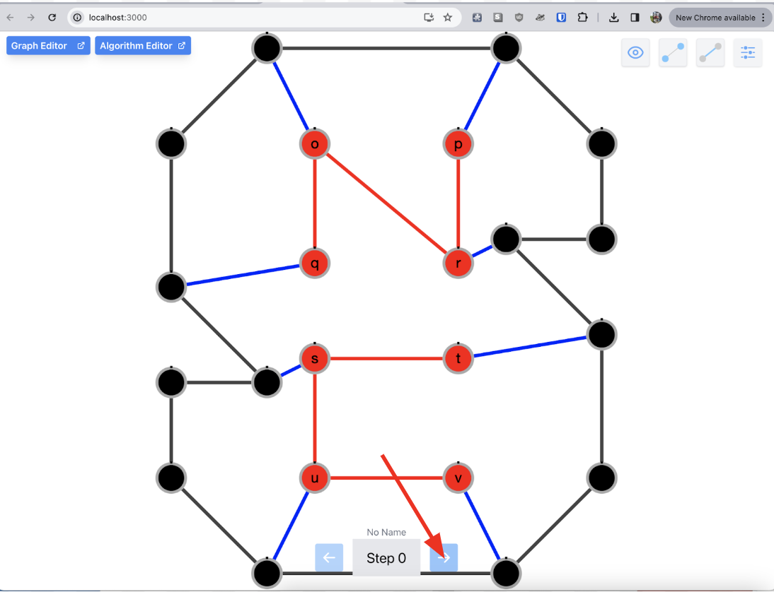

3. If prompted for a start node, enter the numeric value of the node that you would like to start the graph from.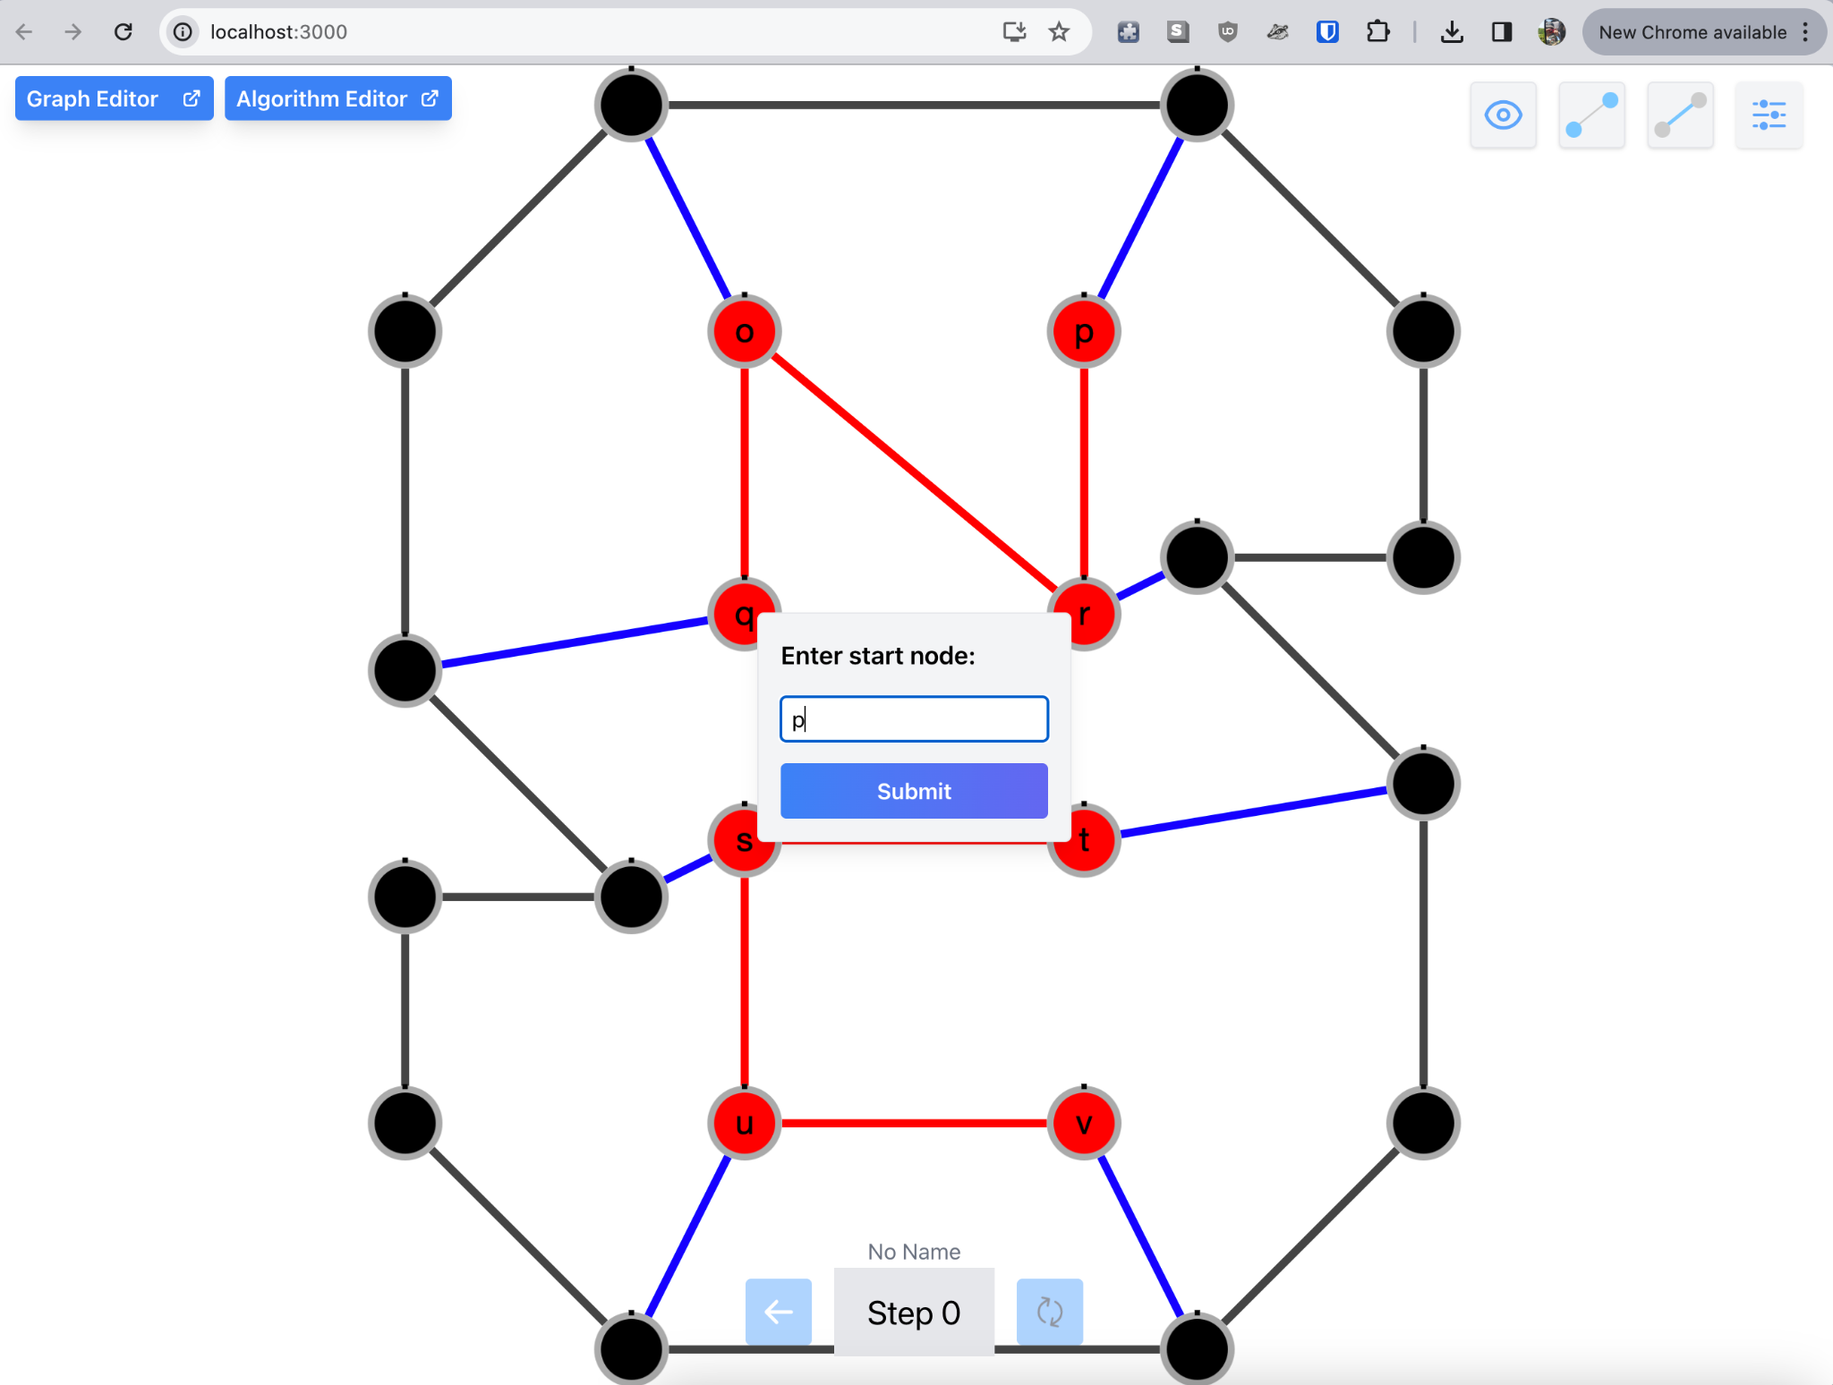

4. Keep clicking on the front step button to traverse through the graph.

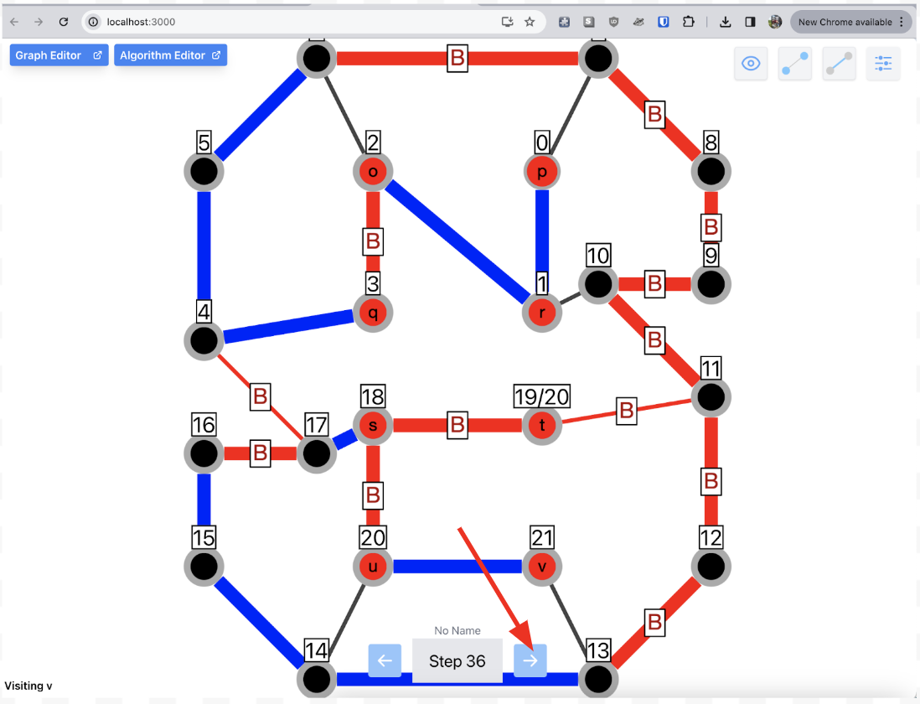

5. Click on the back arrow to trace back to a previous algorithm step on the graph.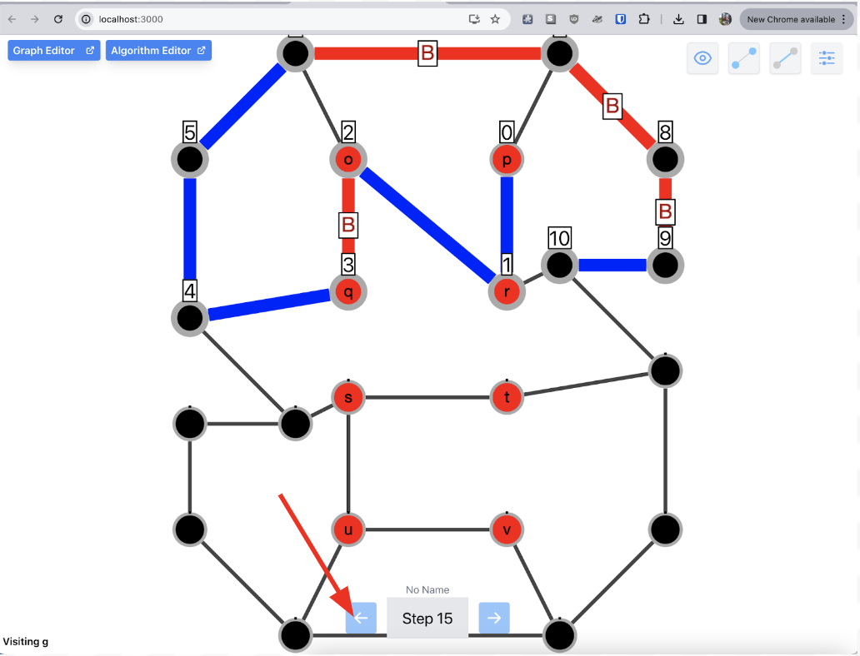

## **Exiting an Algorithm**

1. Ensure that the algorithm and the graph are loaded and running.

2. On the keyboard, hit the escape key to exit the algorithm, or click the small ‘x’ button next to the name of the algorithm above the step counter.

## **Download a Graph/Algorithm**

1. Ensure that a graph has been successfully loaded in the graph editor window.

2. Click the “Download File” Button.

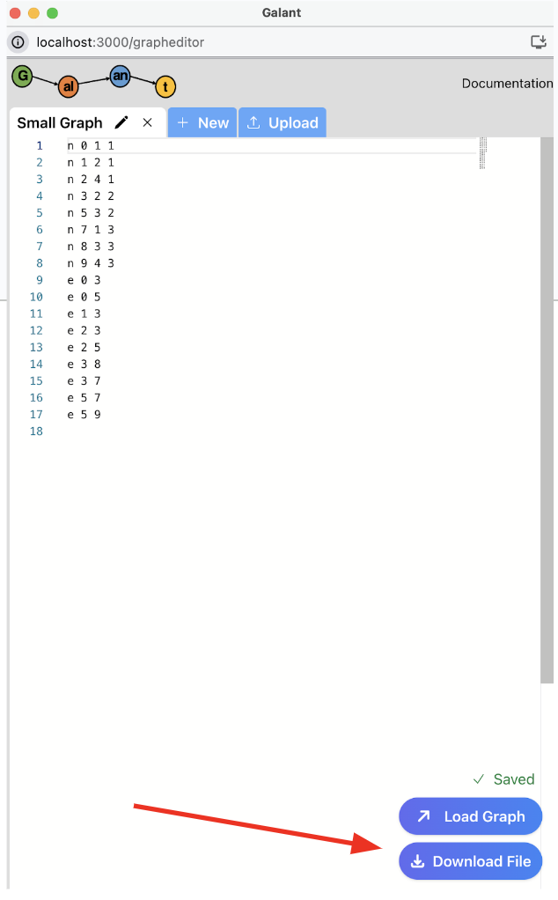

3. Navigate to the save location then press the “Save” button.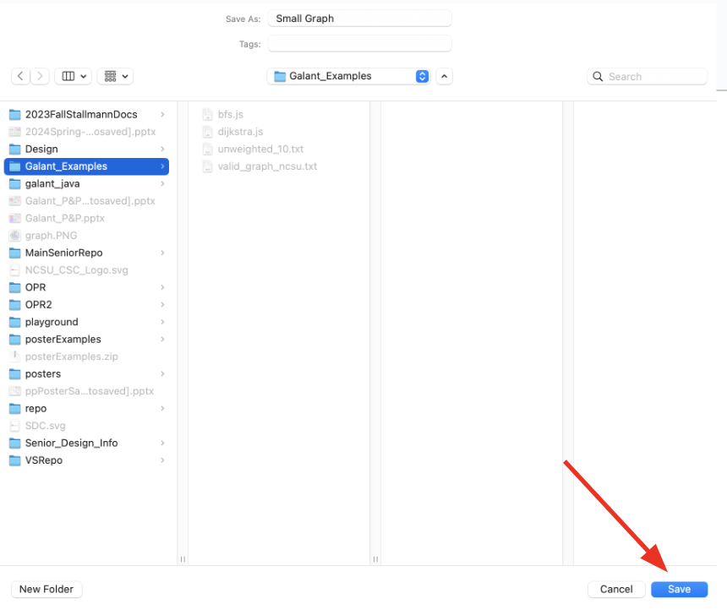

## **Adding Node Label and Weight**

1. Ensure that a graph has been successfully loaded in the main window.

2. Right click on a node you wish to add a label or weight to.

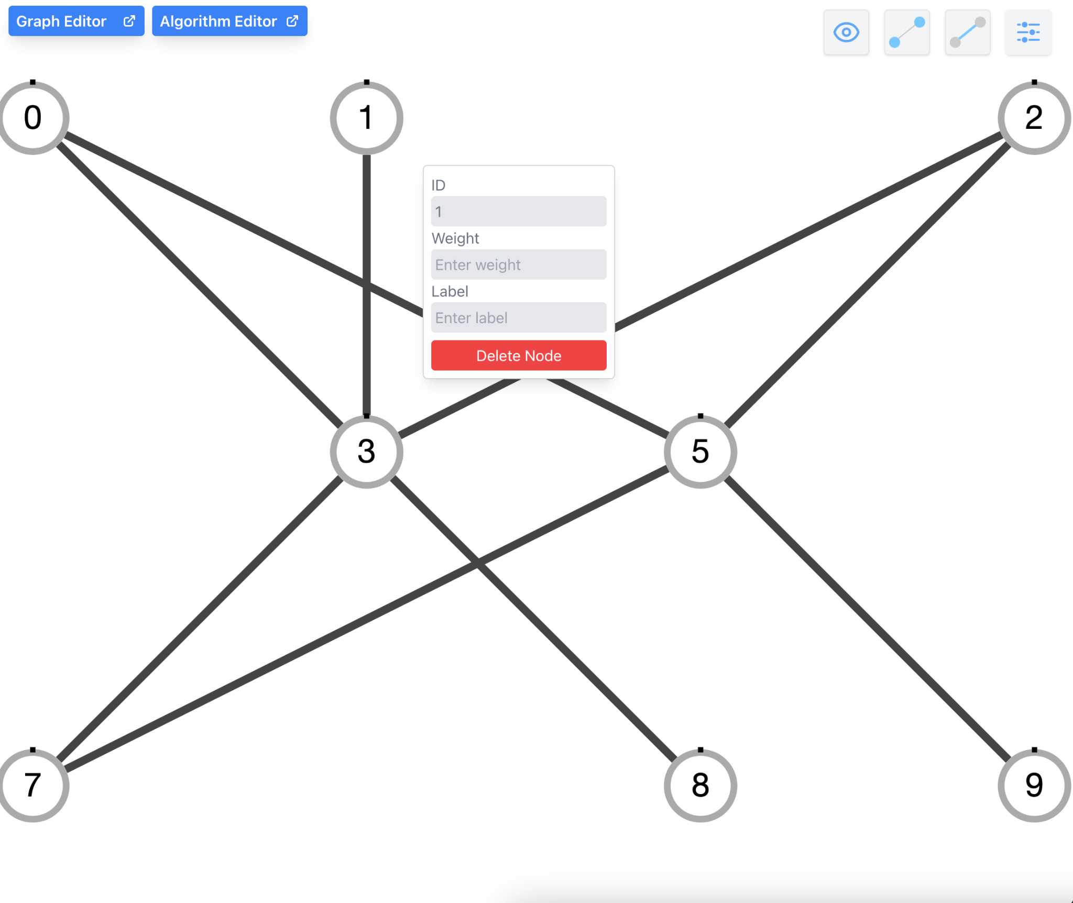

3. Enter the label name and weight of the node.

4. Click off to the side of the pop-up to save the node changes.

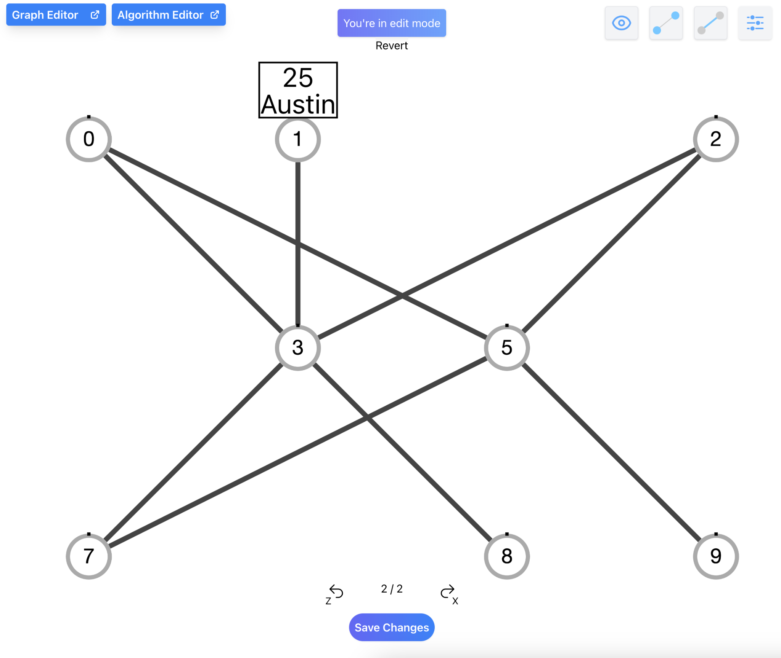

## **Editing Node Label and Weight**

1. Ensure that a graph has been successfully loaded in the main window.

2. Right-click a node you wish to edit.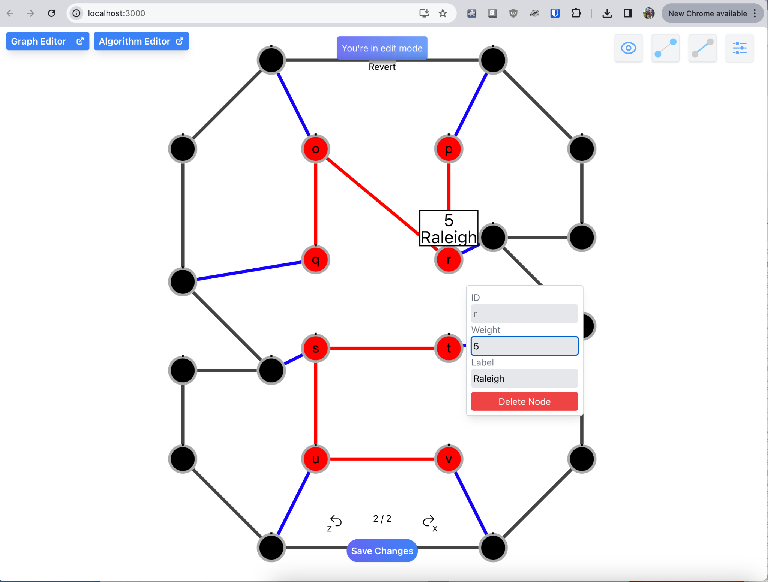

3. In the pop-up box, enter your new desired weight and label for that node.

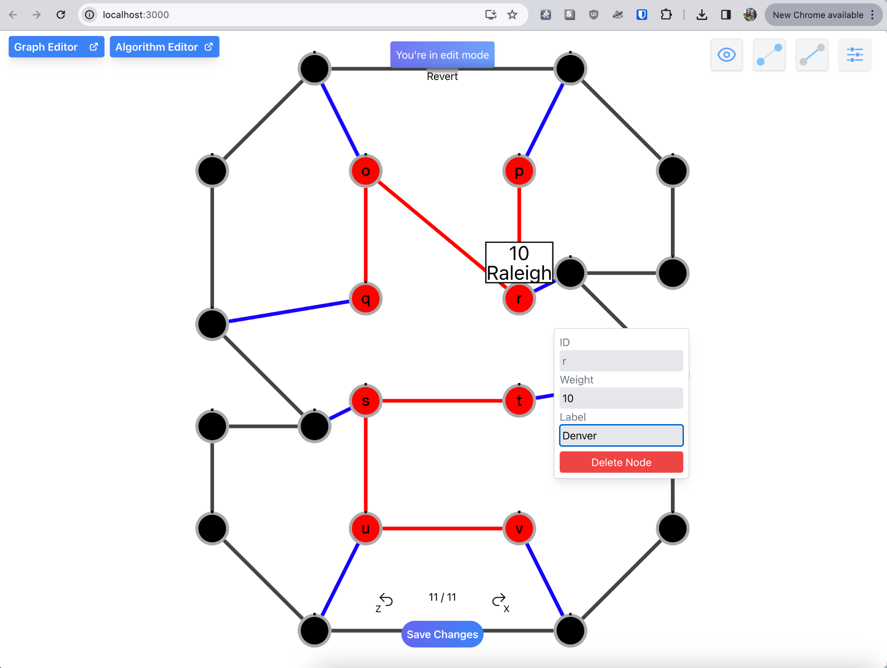

4. Click off the node and the changes will be updated on the node.

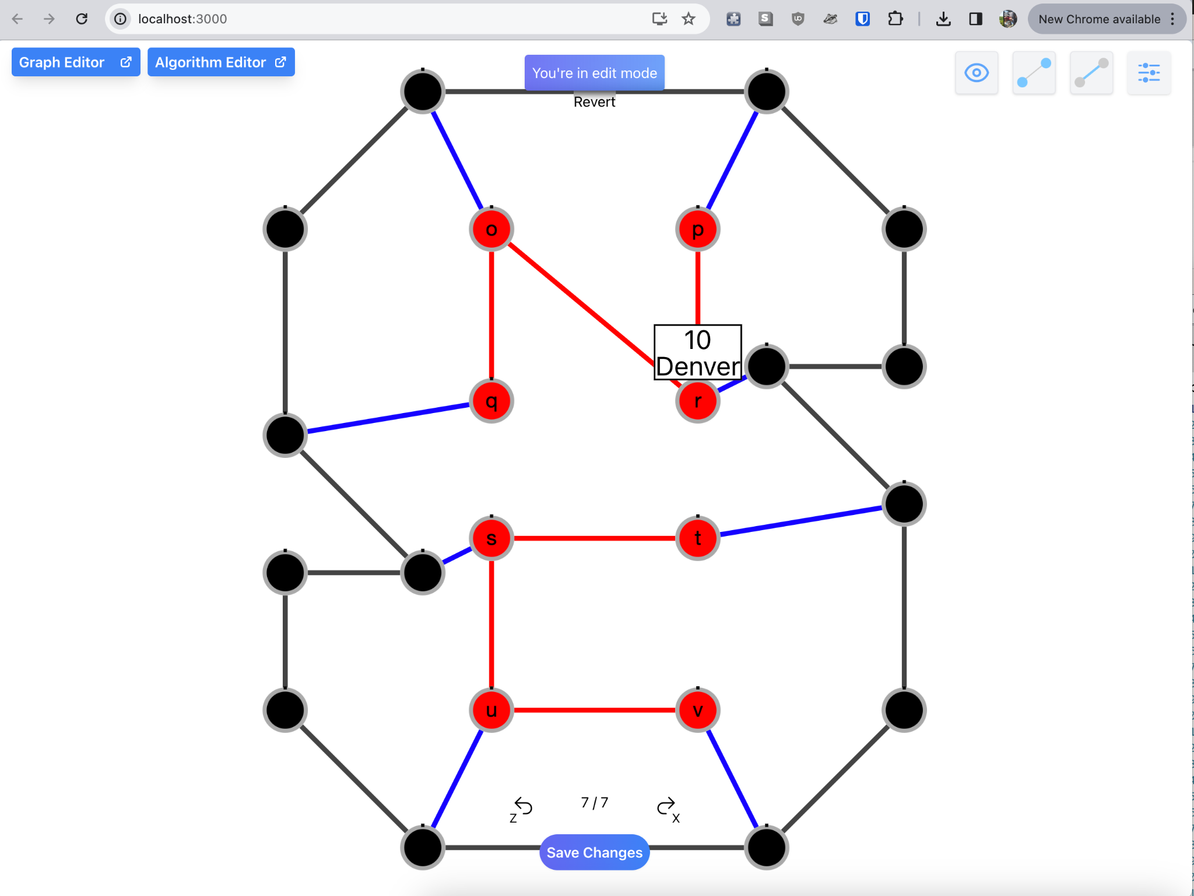

## 

## **Adding Edge Label and Weight**

1. Ensure that a graph has been successfully loaded in the main window.

2. Right-click on an edge to which you wish to add a label or weight.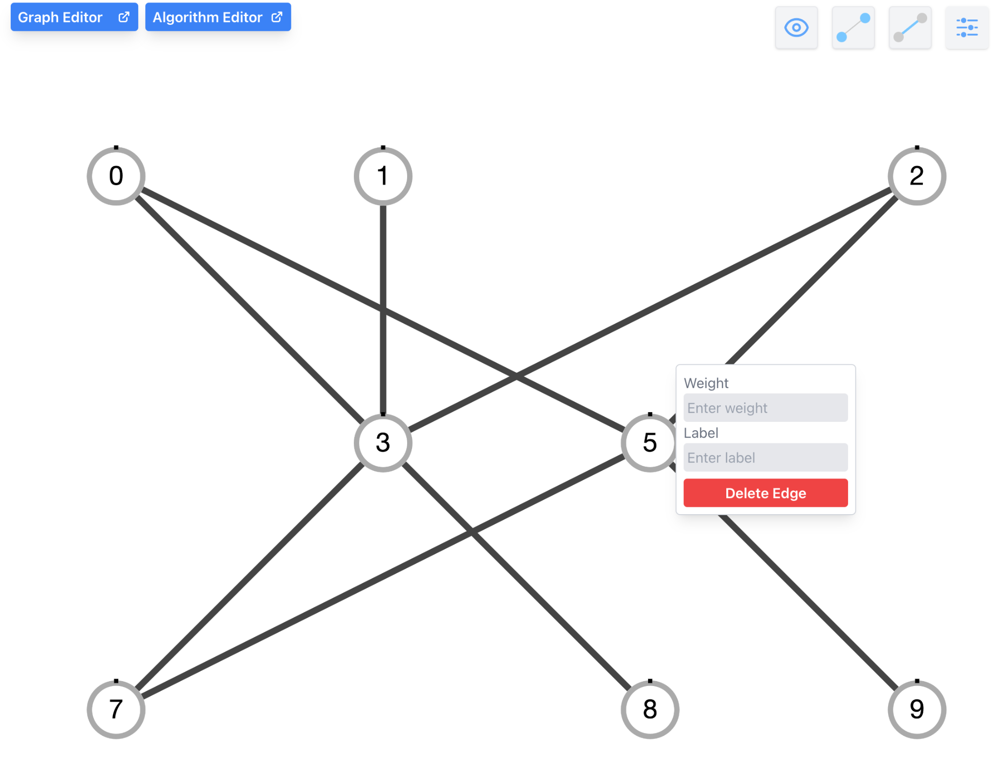

3. Enter the label name and weight of the edge.

4. Click off to the side of the pop-up to save the node changes.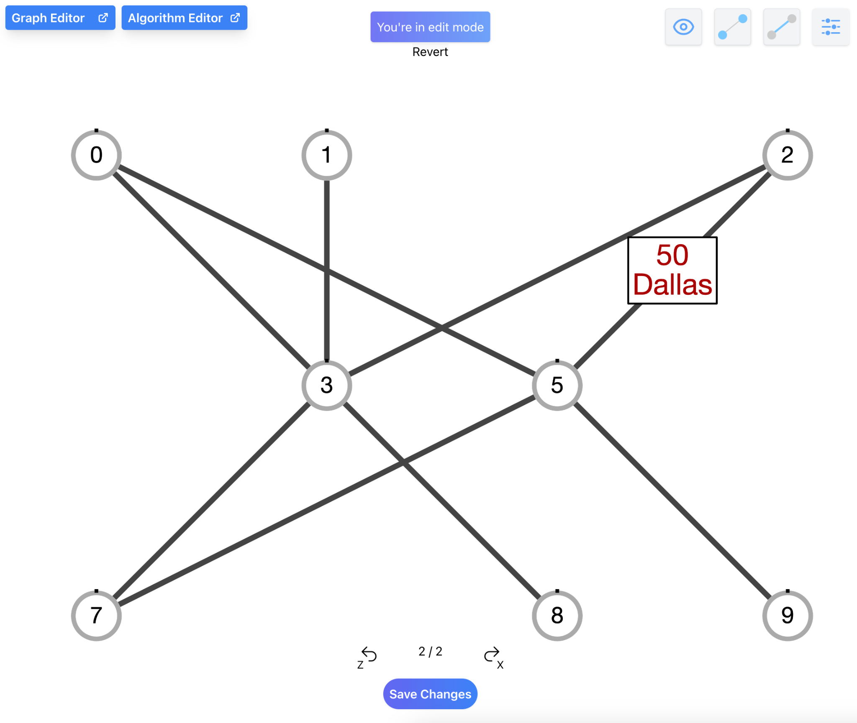

## 

## **Editing Edge Label and Weight**

1. Ensure that a graph has been successfully loaded in the main window.

2. Right-click an edge you wish to edit.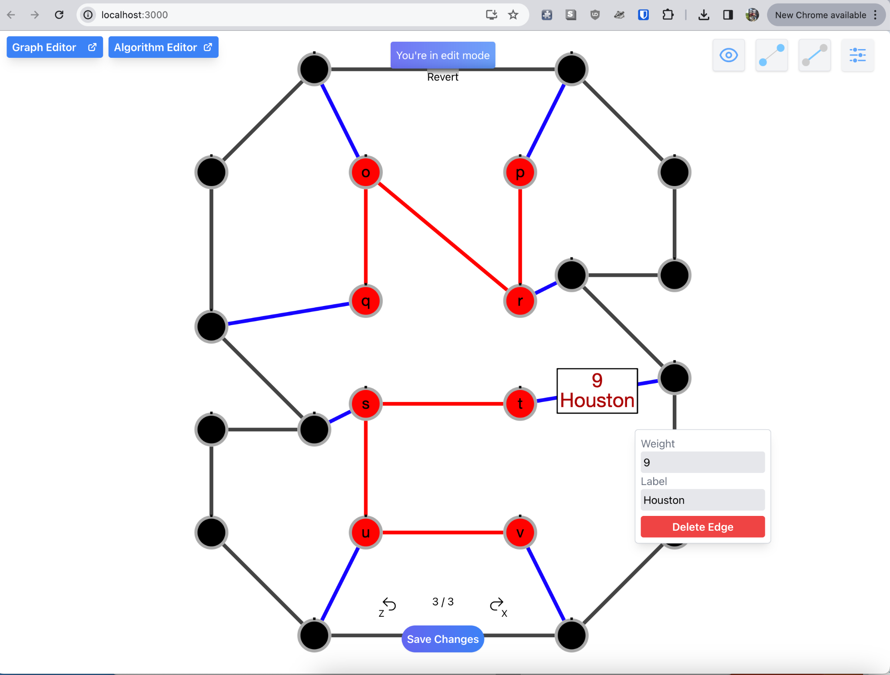

3. In the pop-up box, enter your new desired weight and label for that edge.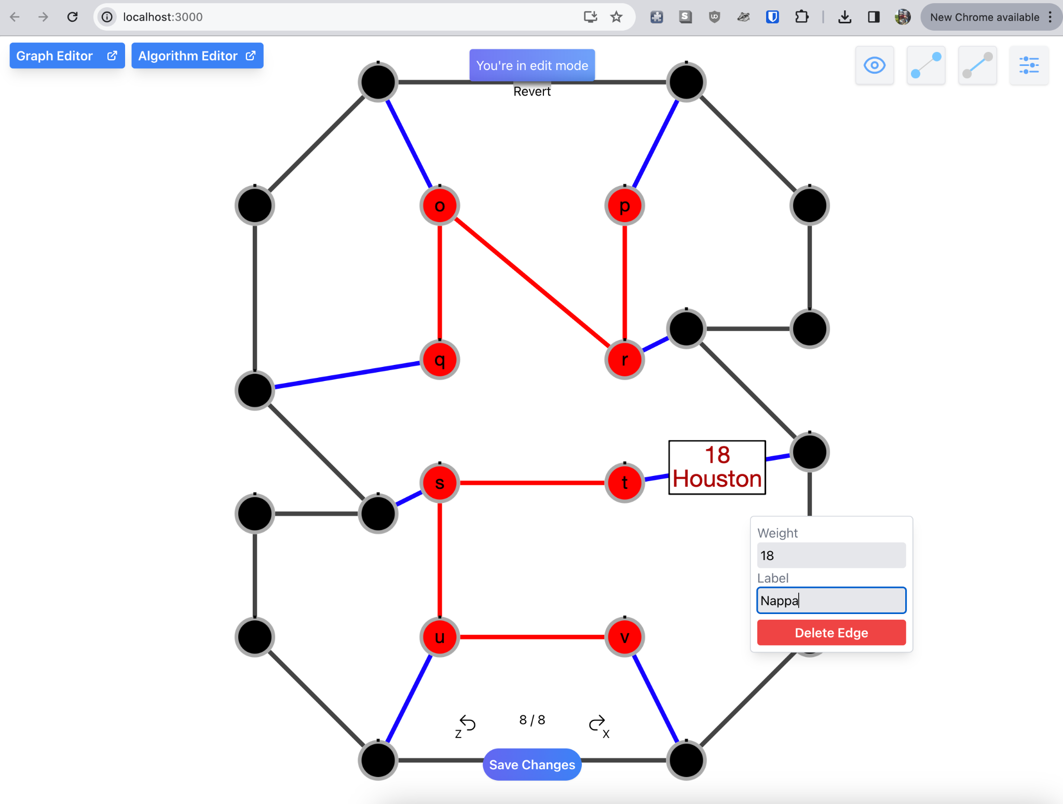

4. Click off the edge and the changes will be updated on the node.

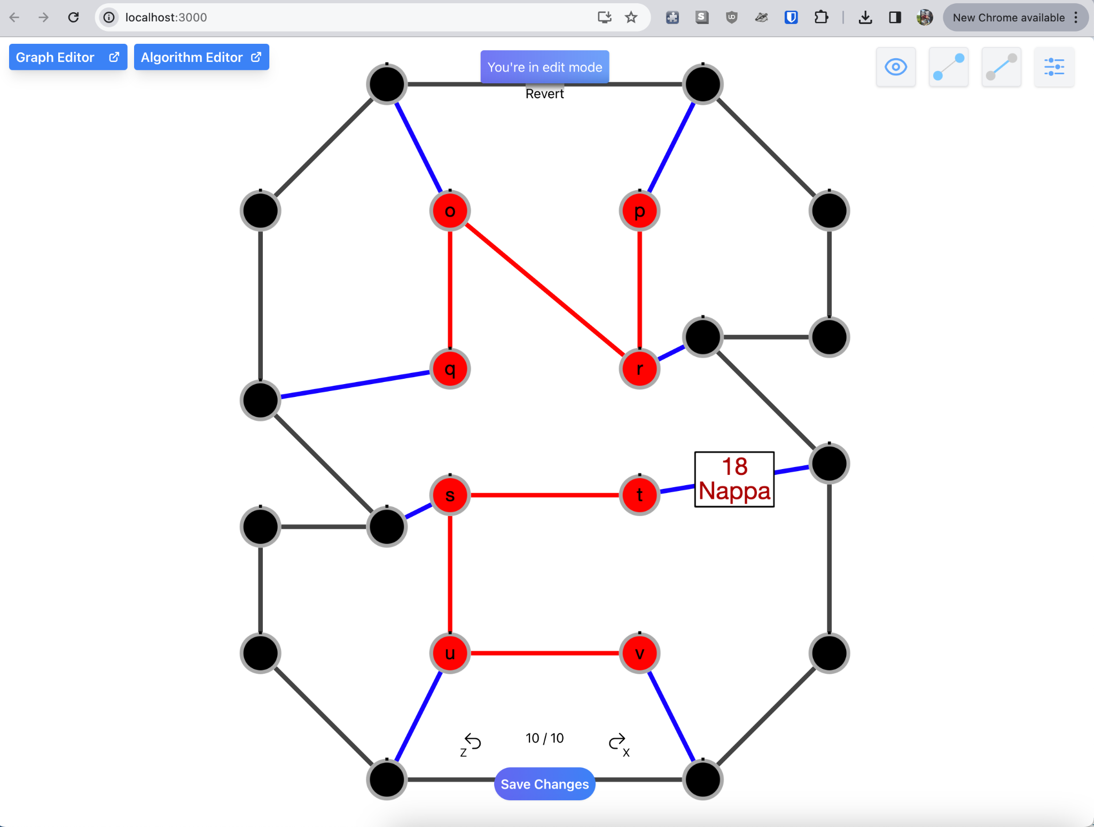

## 

## **Editing a Graph in Edit Mode**

1. Ensure that a graph has been successfully loaded in the main window.

2. To make changes to a graph, you can drag nodes/edges, edit nodes/edges, and create nodes/edges. These changes will be reflected as a count below.

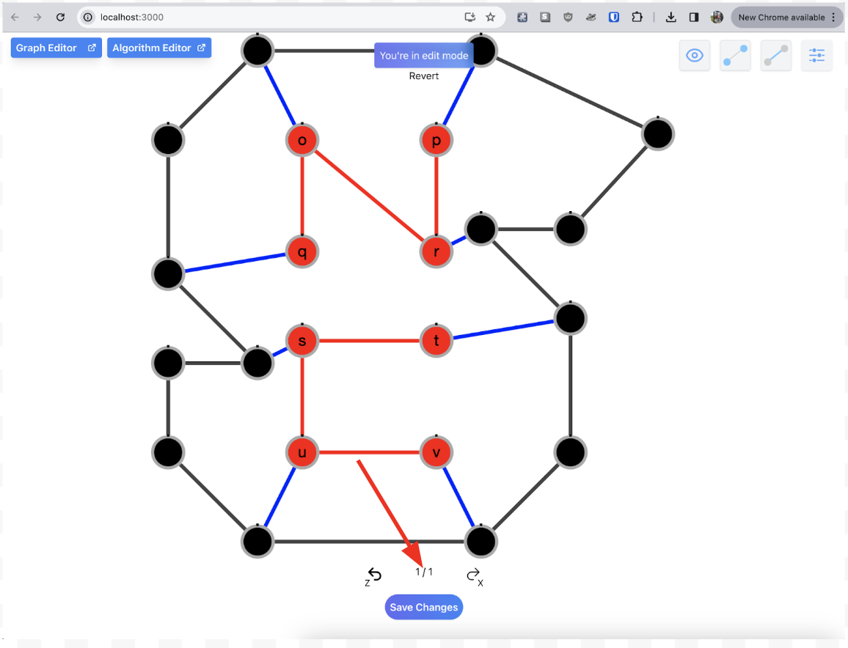

2. To undo any changes press the back button or the ‘z’ key on your keyboard.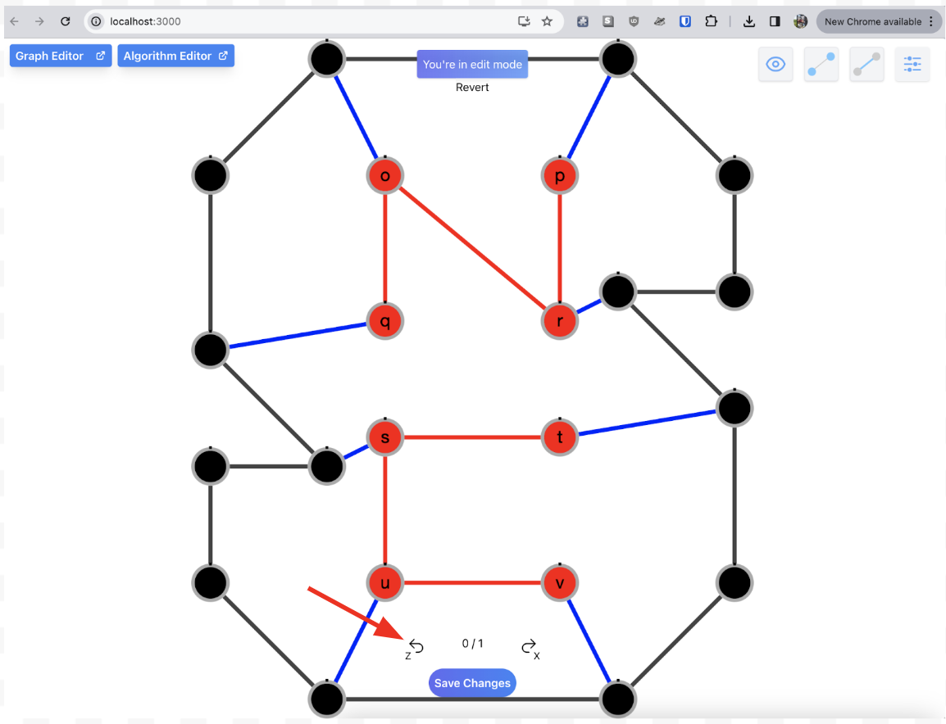

3. To redo any changes previously made press the forward button or the ‘x’ key on your keyboard.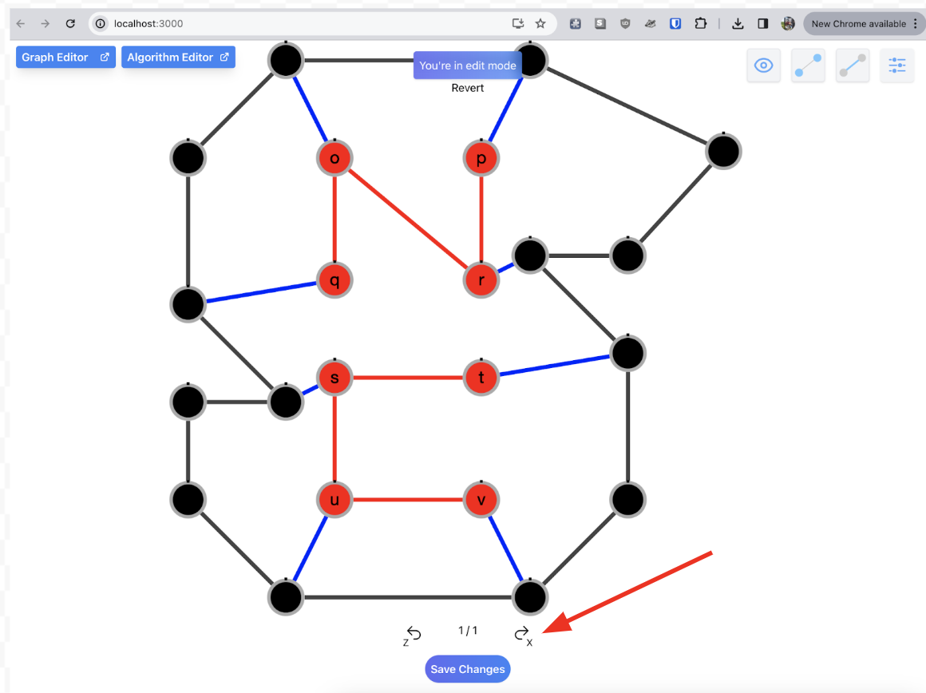

3. To save changes made to the graph, click the “Save Changes” button. This will bring you out of edit mode and into graph mode.

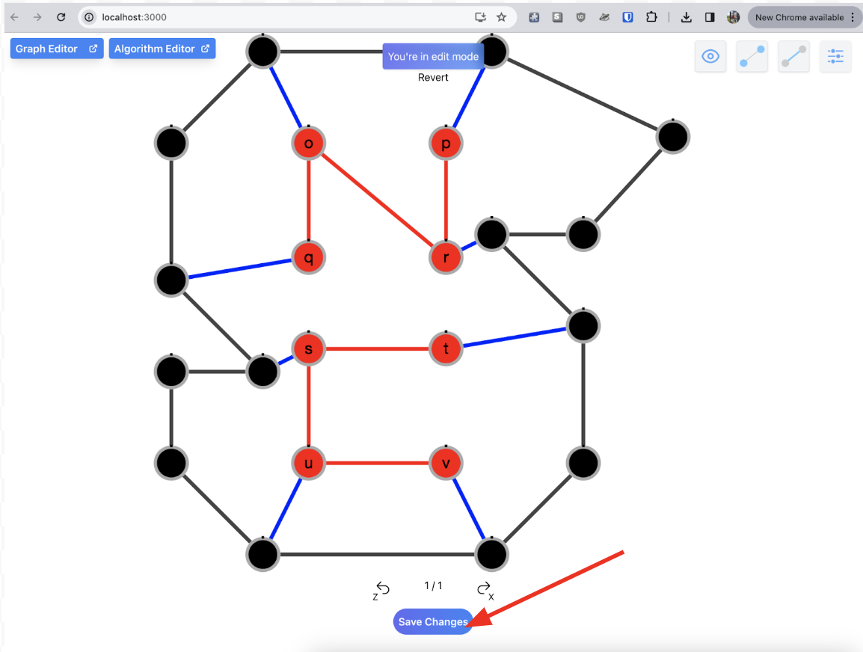

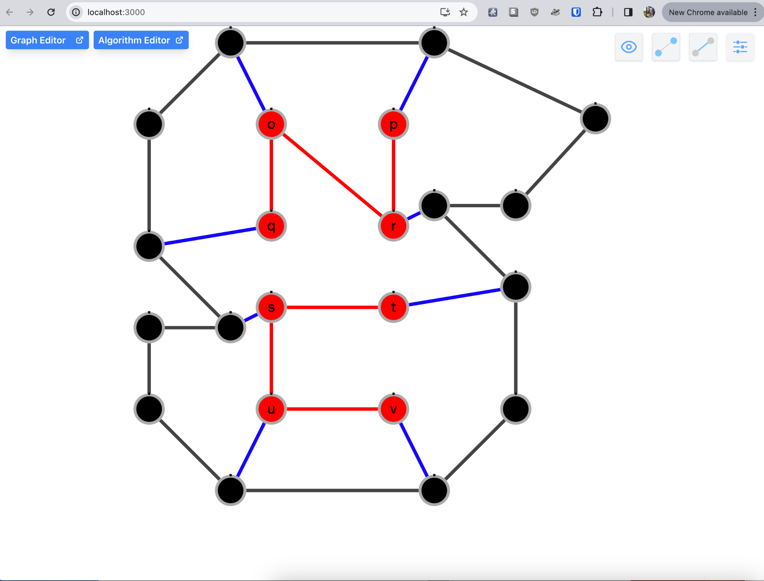

## **Editing Graph text**

1. Ensure that a graph has been successfully loaded in the main window.

2. Any changes made in Graph Editor will be reflected in the graph currently loaded in the main window. As seen below, the color for node number five is blue. To change this color we need to update its node attribute of ‘color’.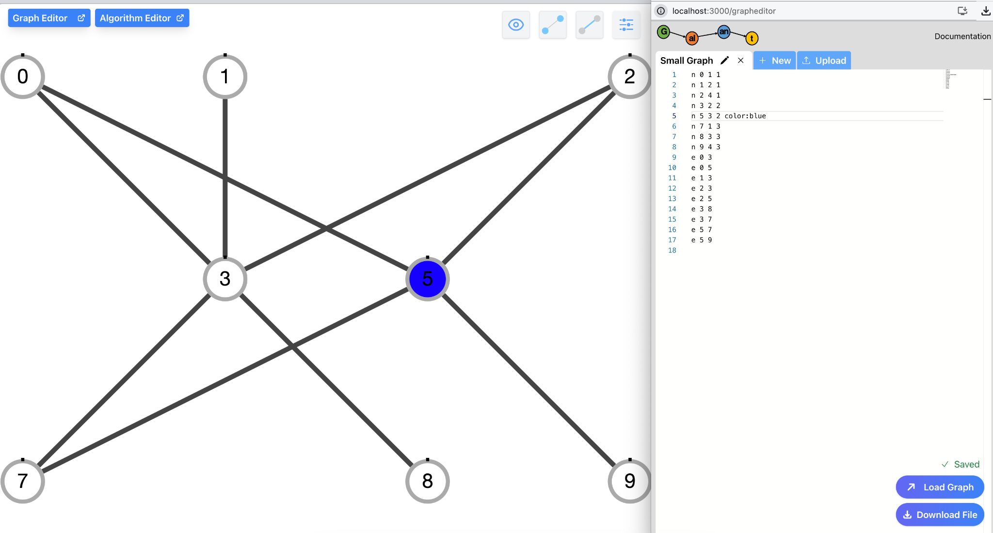

3. In the Graph text editor, change the ‘color:blue’ to ‘color:pink’.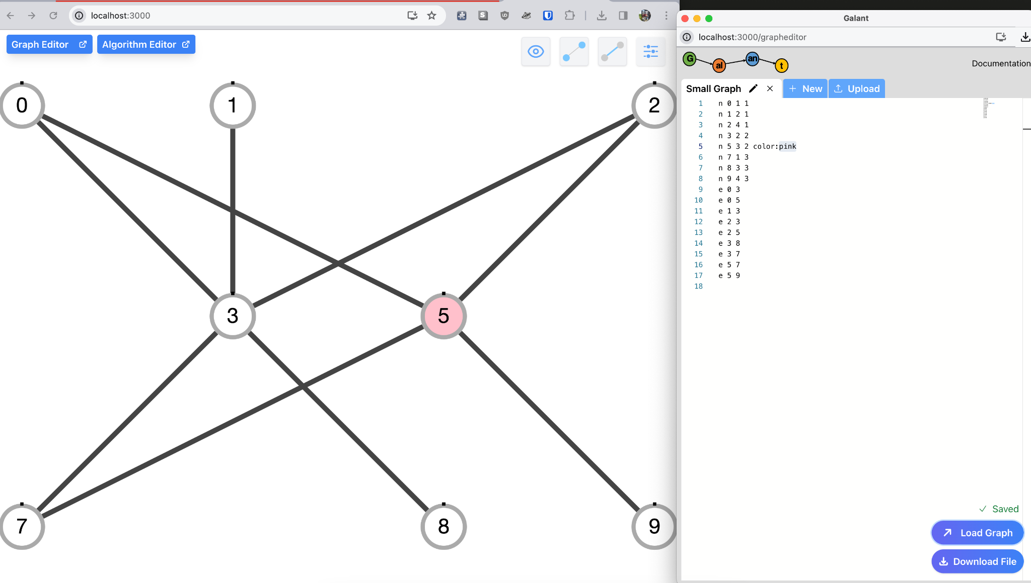

3. Load the graph and reflect on the changes.



## 

## **Editing Algorithm Text**

1. Ensure that an algorithm has been successfully loaded in the main window.

2. Any changes made in Algorithm Editor will be reflected in the graph currently loaded in the main window. As seen below, the edge highlight color for an edge that has not been visited yet is blue. But what if we want to change the color?

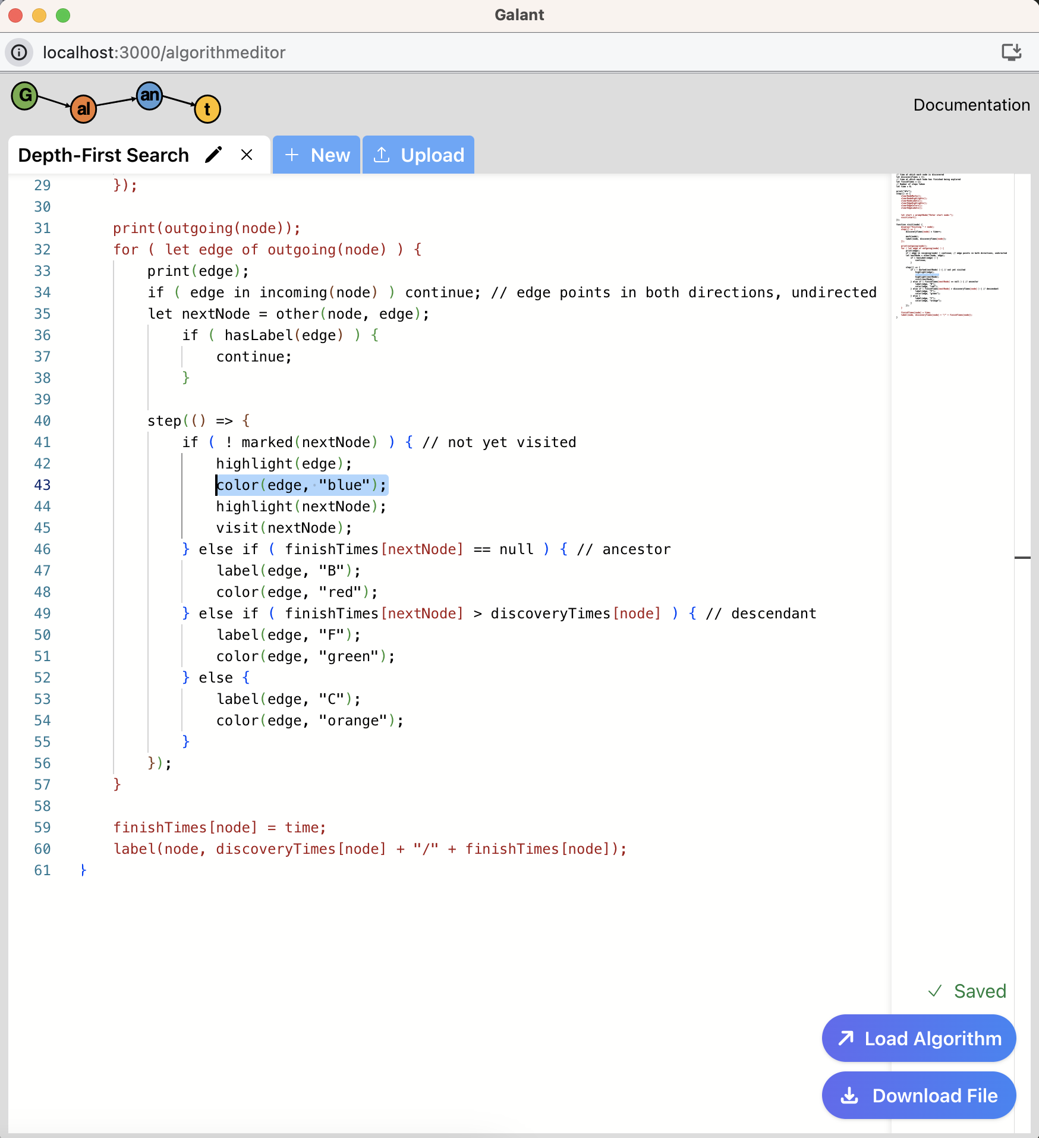

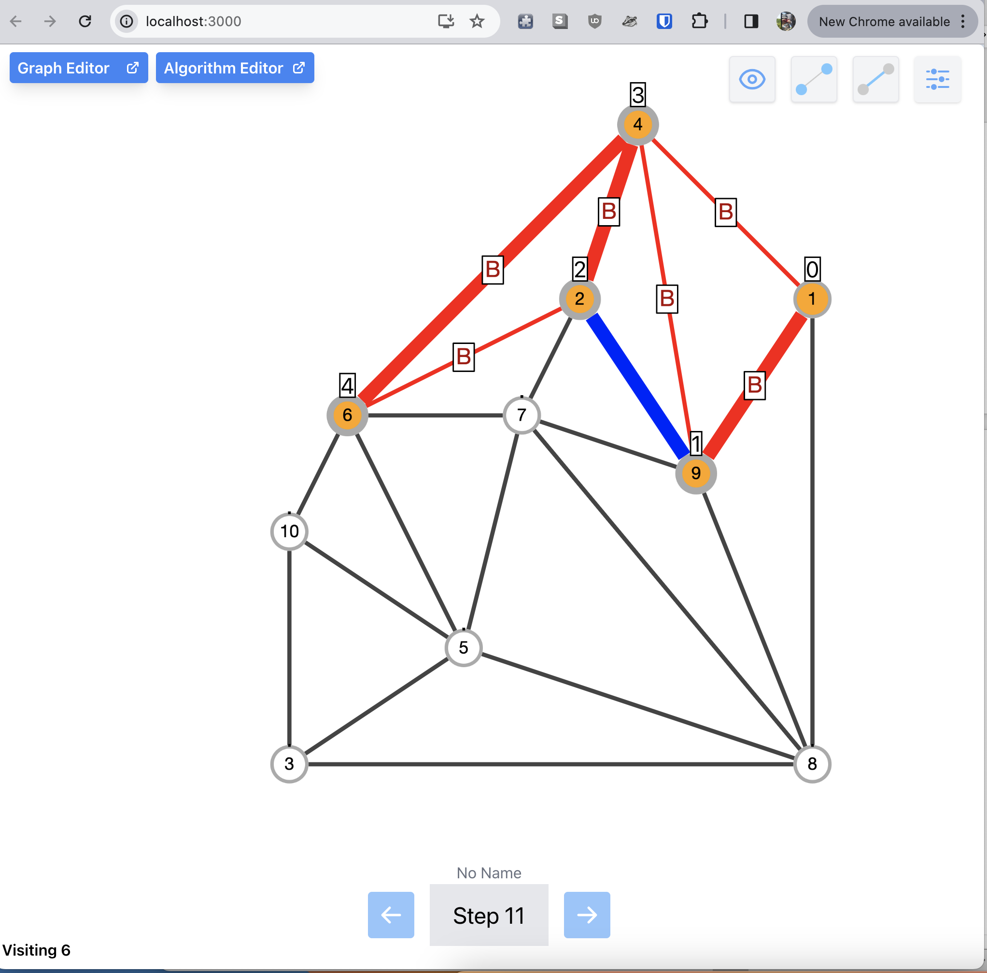

3. For example, to change the edge highlight color on an Unweighted graph from blue to purple we can edit the Depth-First Search algorithm in the Algorithm Editor window. Then click the Load Algorithm button again to reflect these changes.

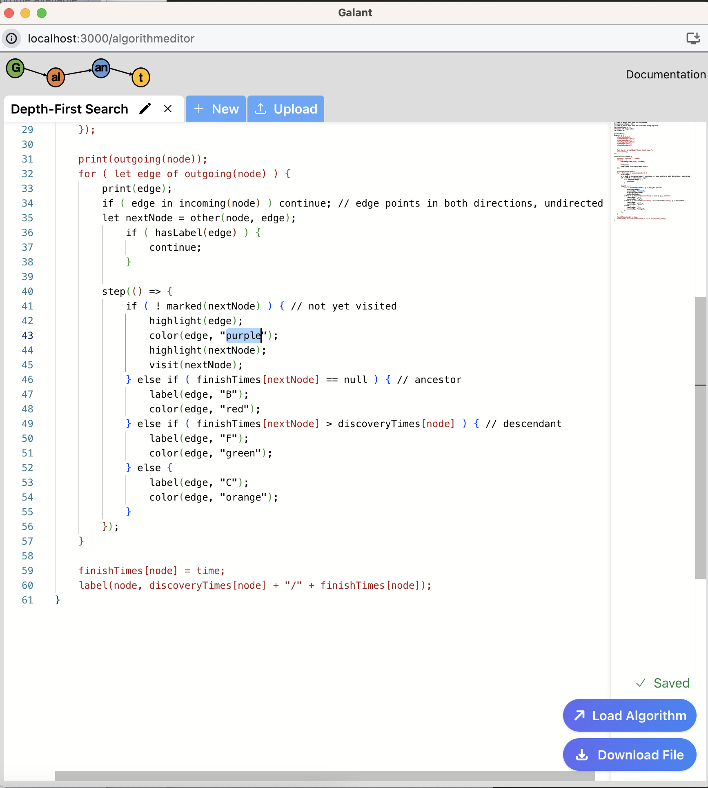

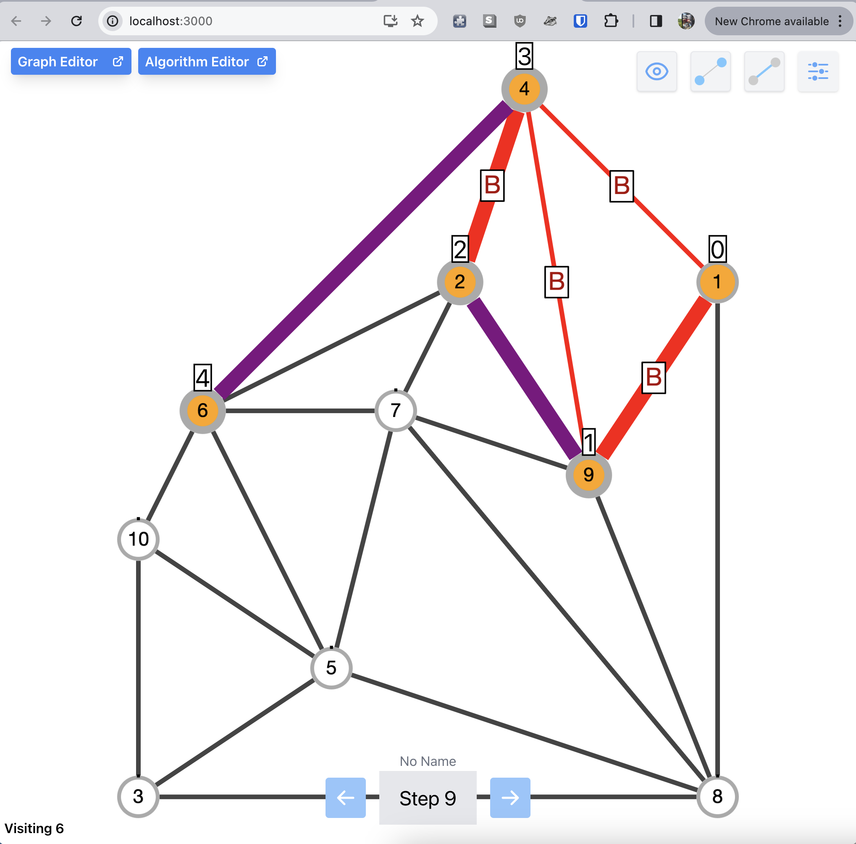

# 

# 

# 

# 

# 

# 

# 

# Keyboard Shortcuts

**Table 1: Keyboard Shortcuts**

| **Keyboard Shortcut** | **Action** | **Description** |
| --- | --- | --- |
| A | Opening Editors | Open Algorithm Editor from Main Page |
| G | Opening Editors | Open Graph Editor from Main Page |
| S | In-Editor Controls | Download Current Graph/Algorithm File in the Editor |
| L | In-Editor Controls | Load Current Graph/Algorithm File in the Editor |
| N | In-Editor Controls | Choose New Graph/Algorithm File in the Editor |
| Z | Edit Mode | Undo Changes |
| X | Edit Mode | Redo Changes |
| R | Edit Mode | Revert Graph back to original state |
| S | Edit Mode | Save Changes |
| Left Arrow | Algorithm Controls | Step Back |
| Right Arrow | Algorithm Controls | Step Forward |
| Escape Key | Algorithm Controls | Terminate Algorithm |
| ‘S’ Key | Algorithm Controls | Export Graph |
| Cmd/Win + Right Arrow | Algorithm Controls | Skip to the End of the Algorithm |
| C | Control Settings Popover | Open popover for Layout Controls |
| N | Node Settings Popover | Open popover button for Node Settings |
| E | Edge Settings Popover | Open popover button for Edge Settings |
| P | Preference Popover | Open popover button for Preference Panel |
| H | Help | Open help button |

# 

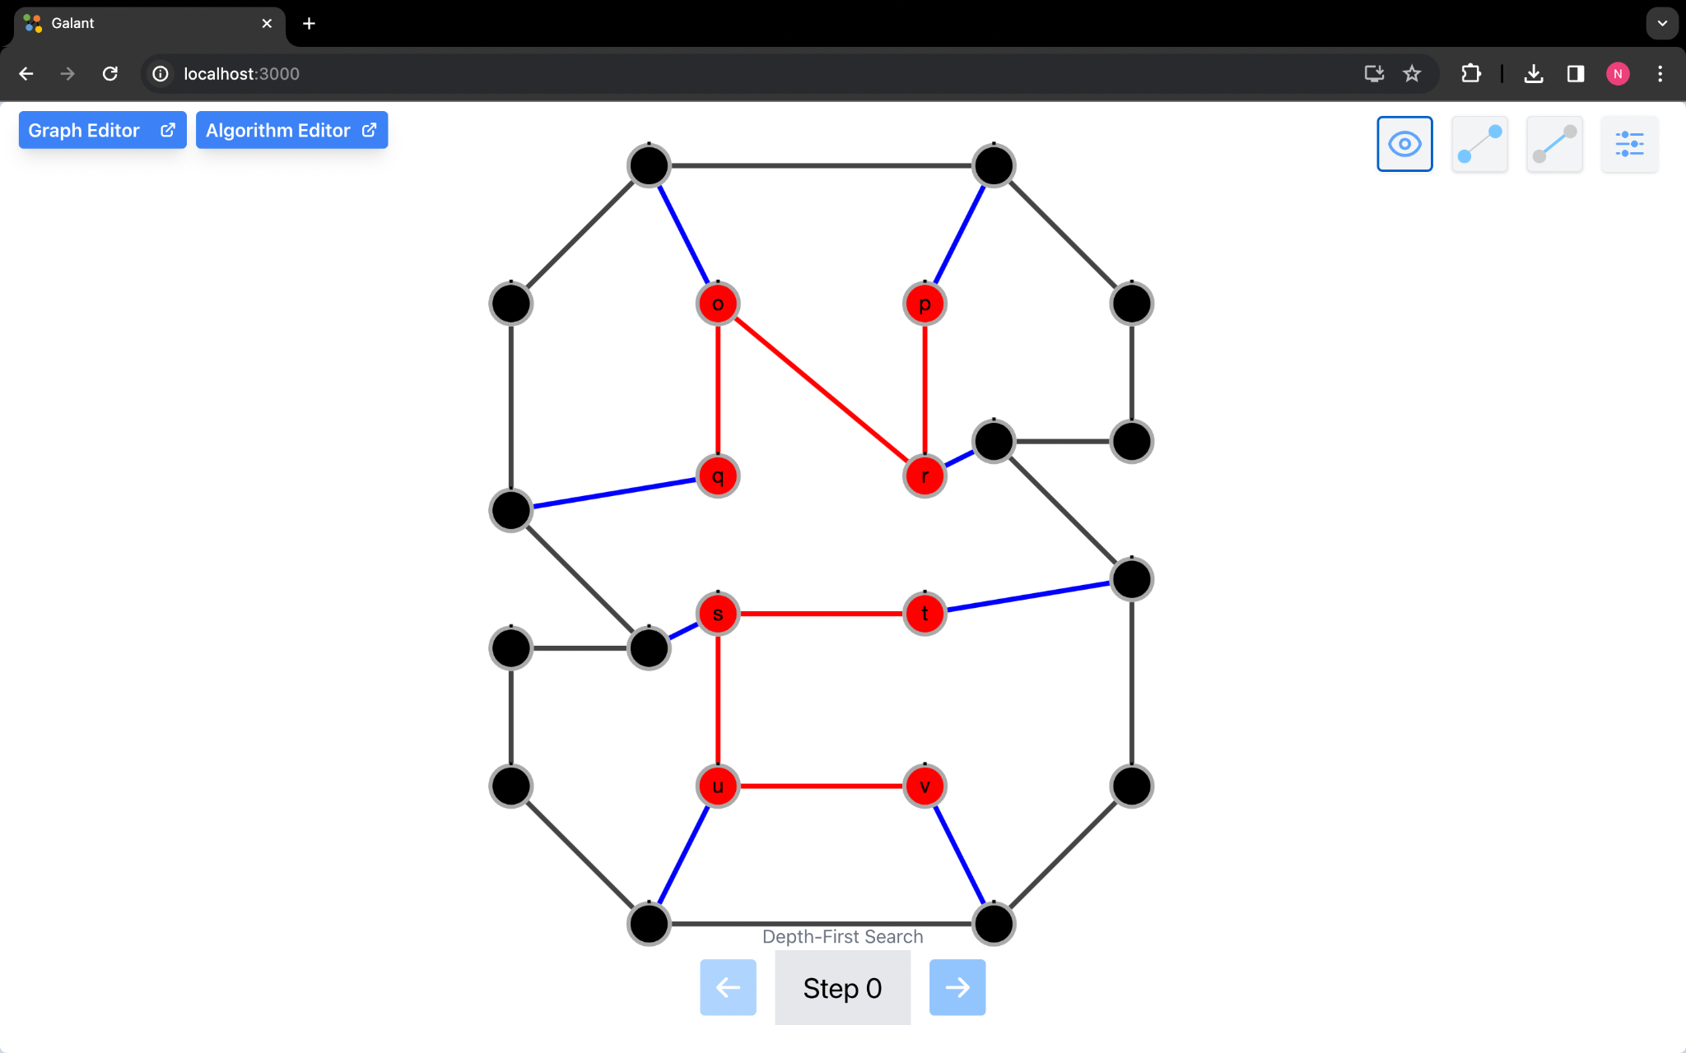

1. The left and right arrow keys can be used to step through the algorithm once it has been loaded. The right arrow key takes the graph a step further through the algorithm.

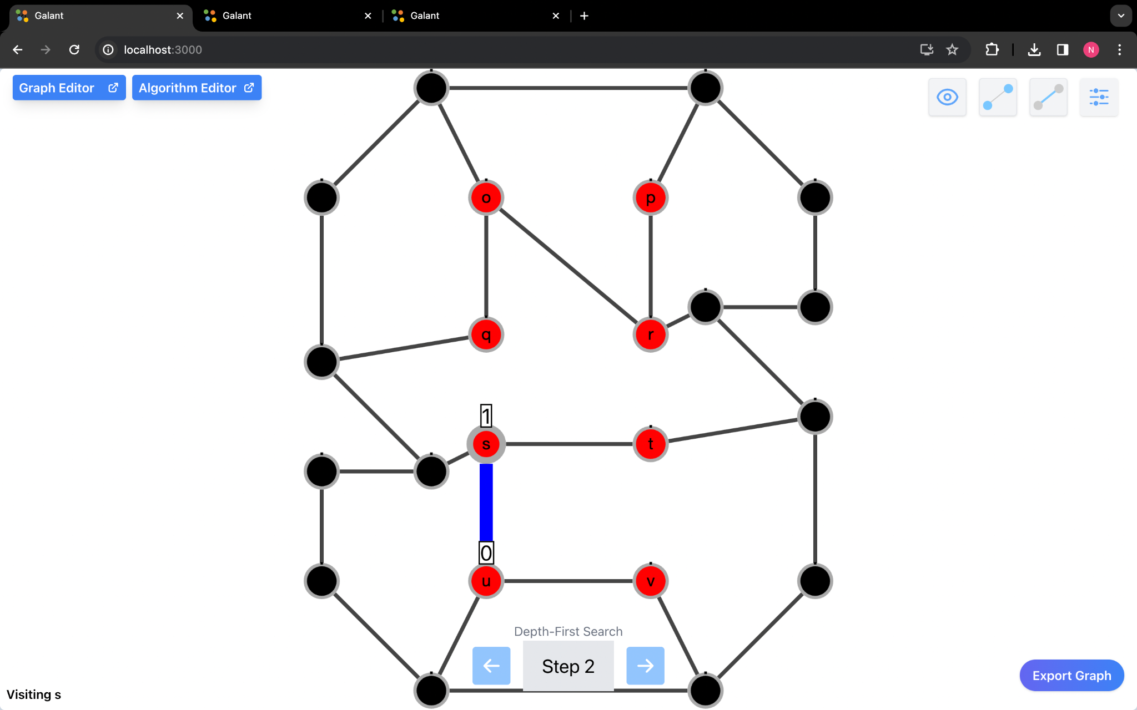

The left arrow key takes the graph a step prior to the current step in the algorithm.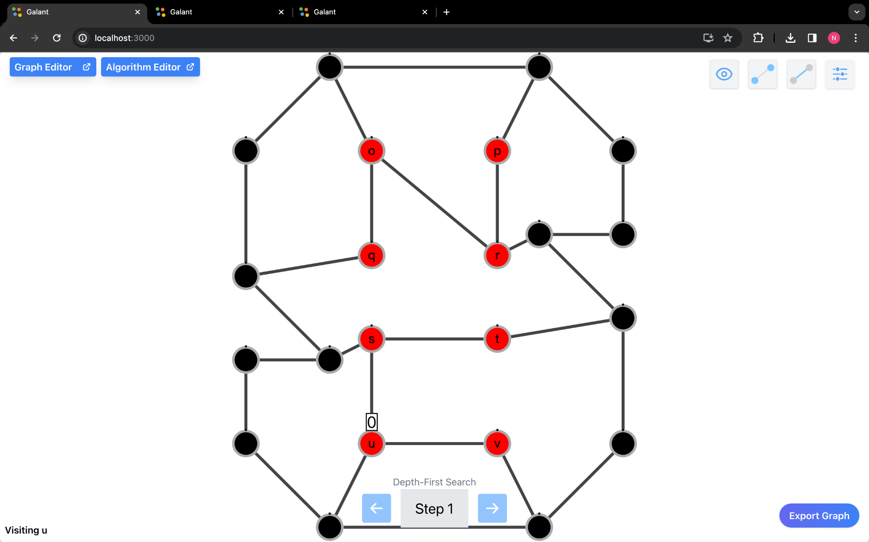

2. The Enter key allows the user to start executing the algorithm immediately after being loaded. The user can load a graph, then load an algorithm, and then press enter to start the algorithm.

3. The toggles on the top right can be triggered by keyboard shortcuts. The controls can be seen by pressing the c key on the keyboard.

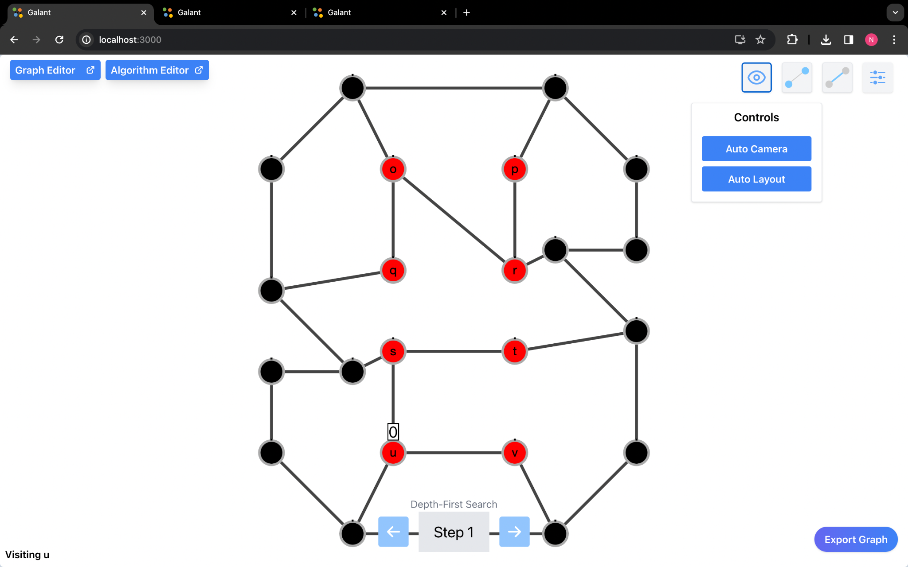

4. The node settings can be seen by pressing the n key on the keyboard

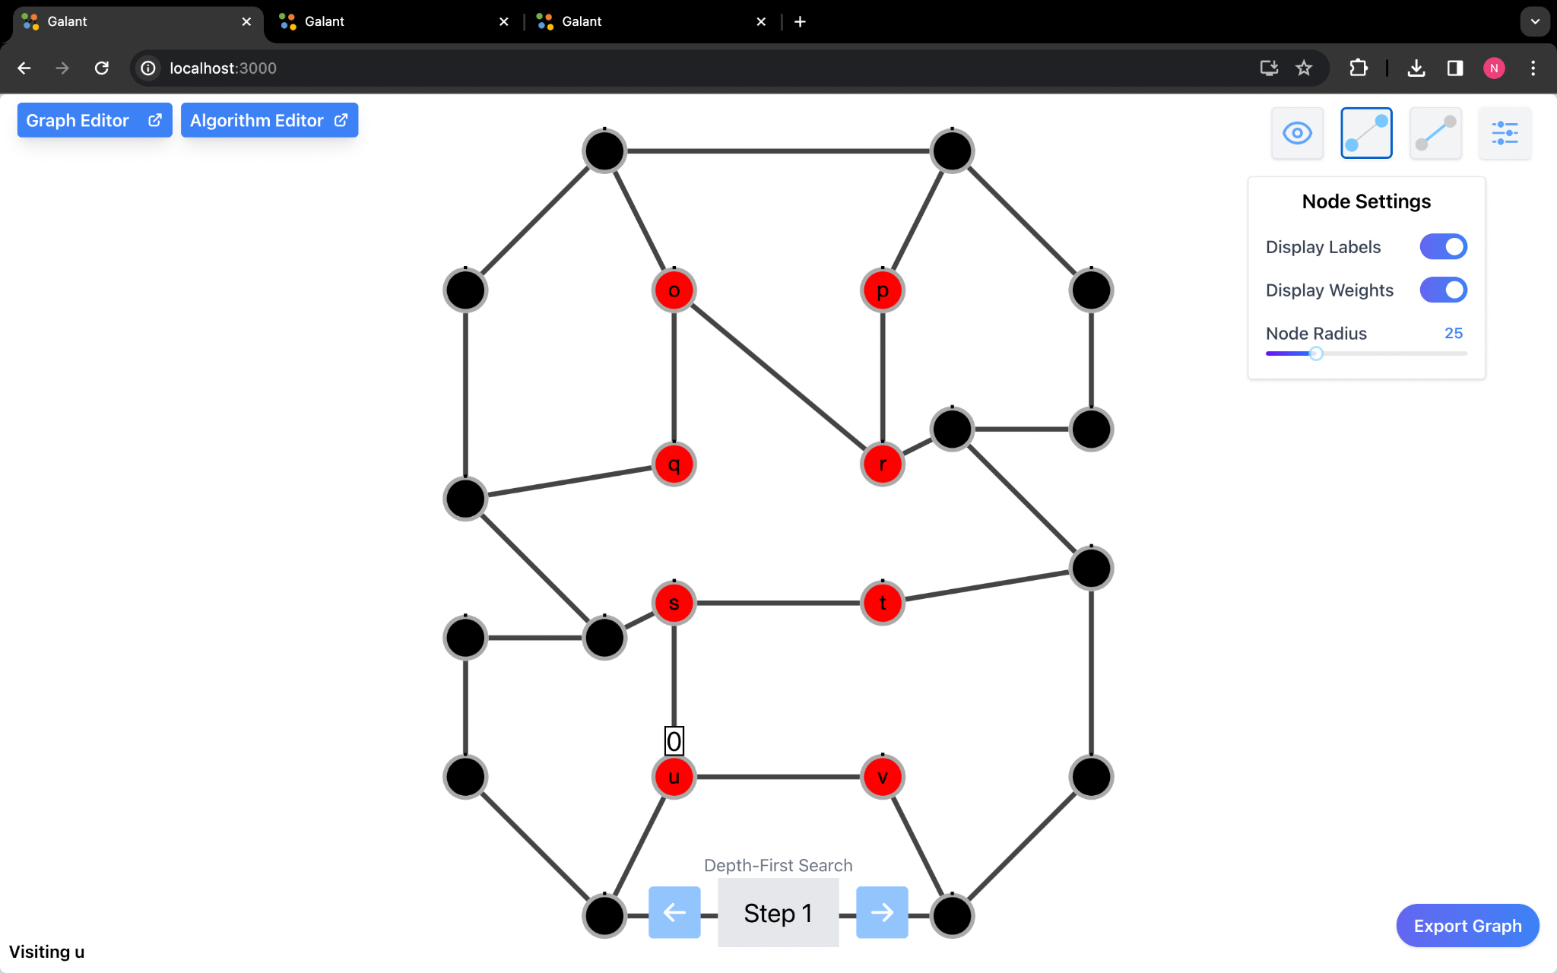

5. The edge settings can be seen by pressing e on the keyboard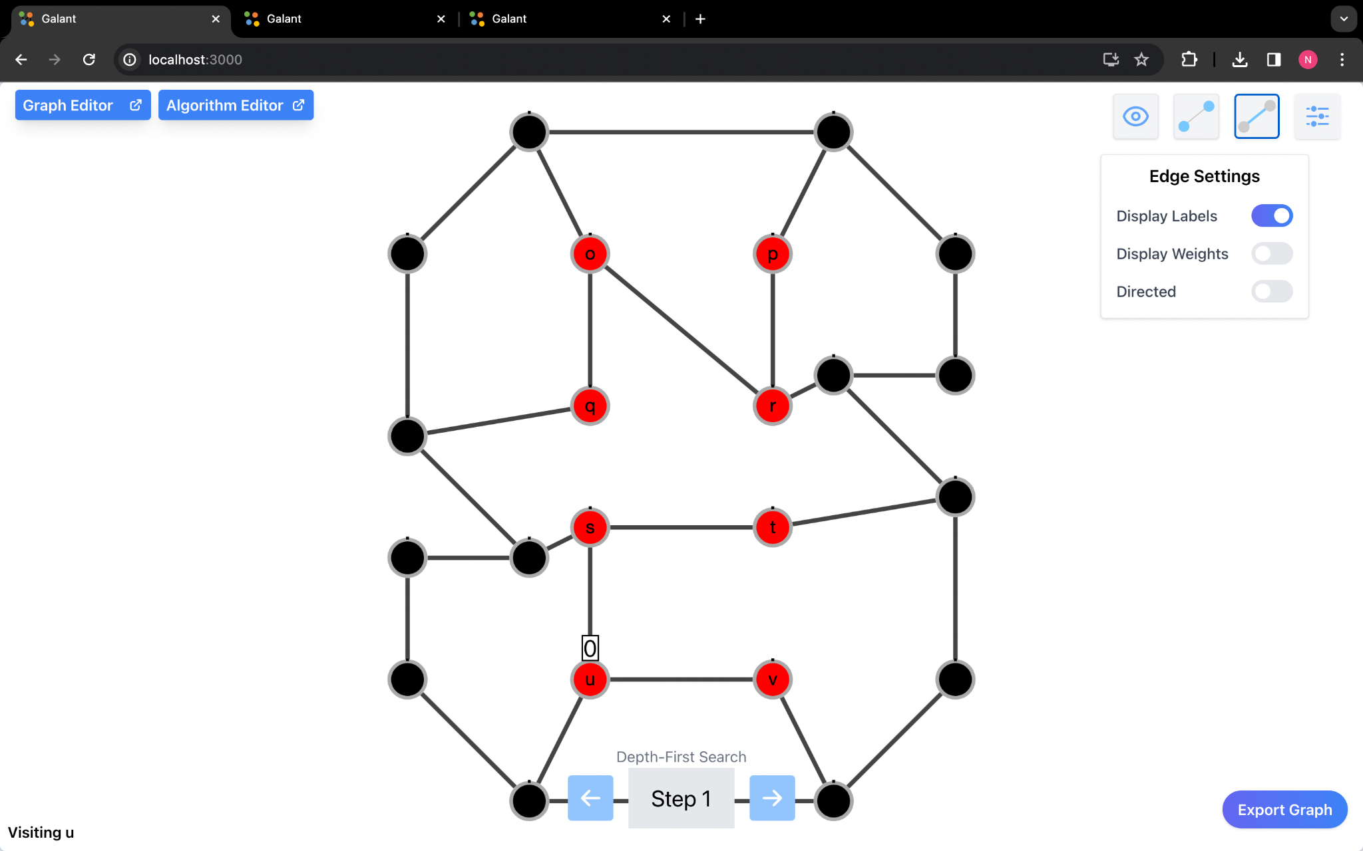

6. The graph preferences can be seen by pressing p on the keyboard

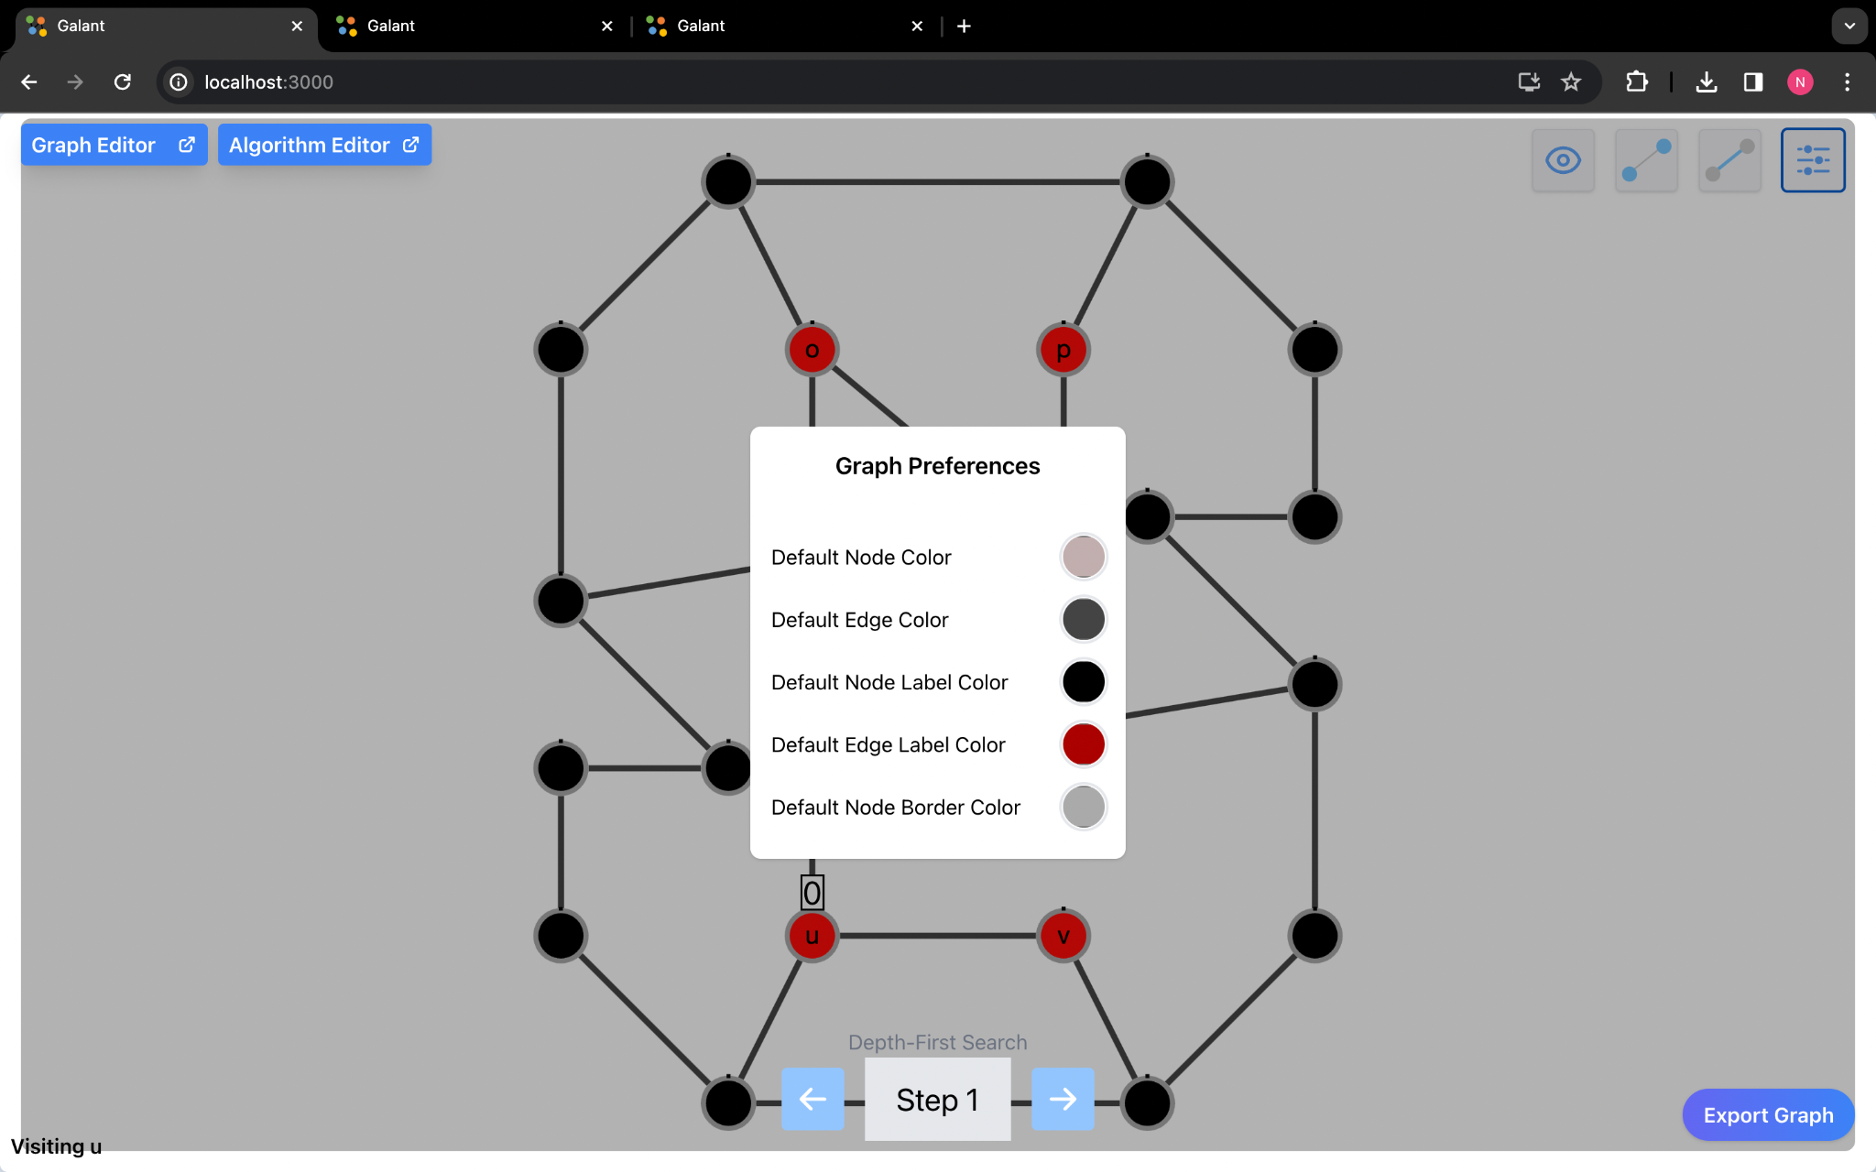

## 

# 

# **Preference Panel**

1.The Graph Preferences Panel allows the user to change the node and edge colors and labels. To access the panel you can either press p as demonstrated above or click on the icon with the slides



1. to change the color of the node you can click on the circle next to the label and choose the color you want to change it to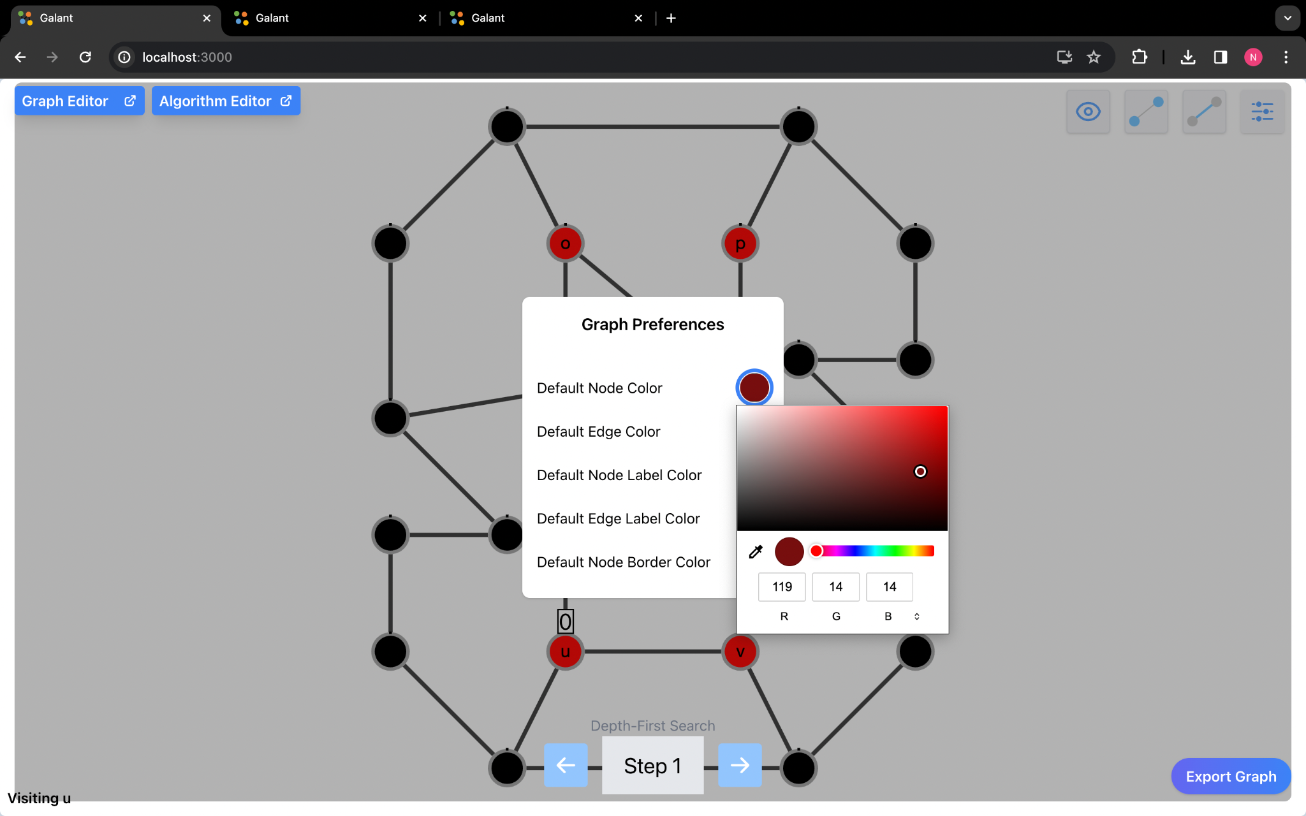
2. to change the color of the edge you can click on the circle next to the label and choose the color you want to change it to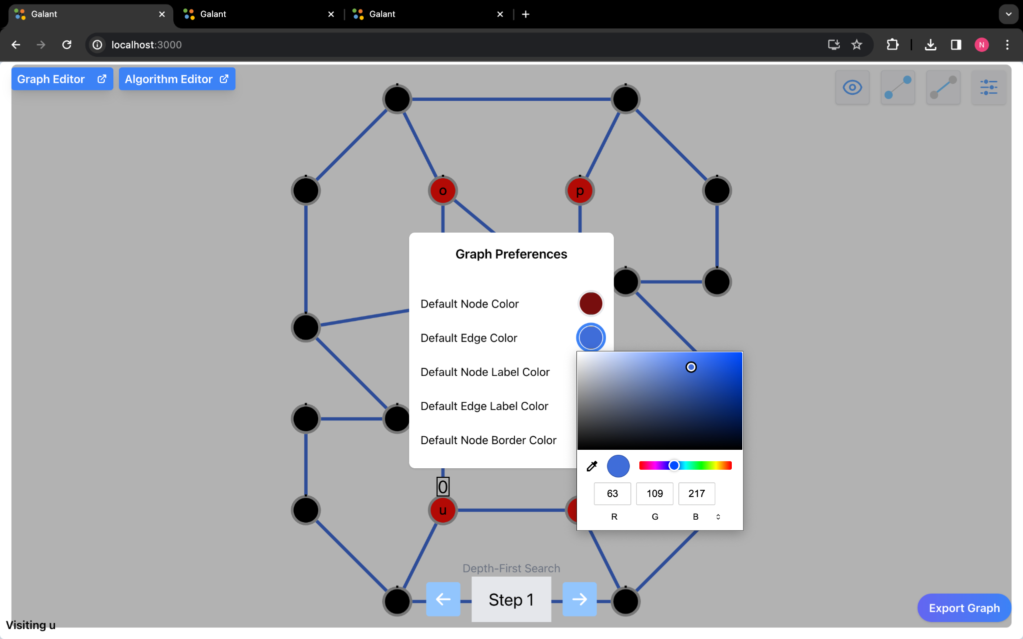
3. to change the color of the label you can click on the circle next to the label and choose the color you want to change it to

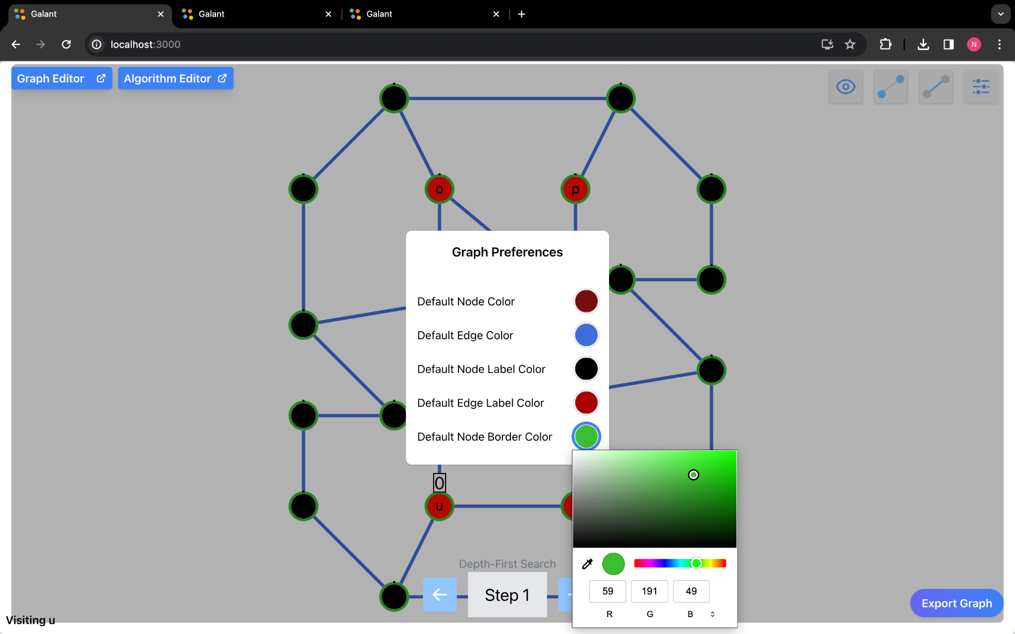

2. The user can access the controls by pressing c or clicking on the eye icon.

1. Clicking on auto camera fits the graph to the page

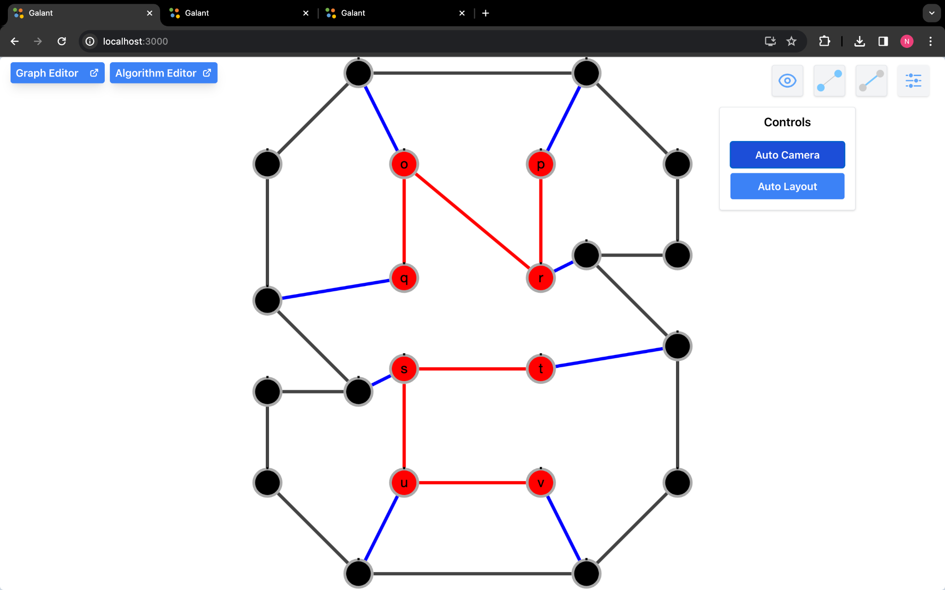

1. Auto layout changes the layout of the graph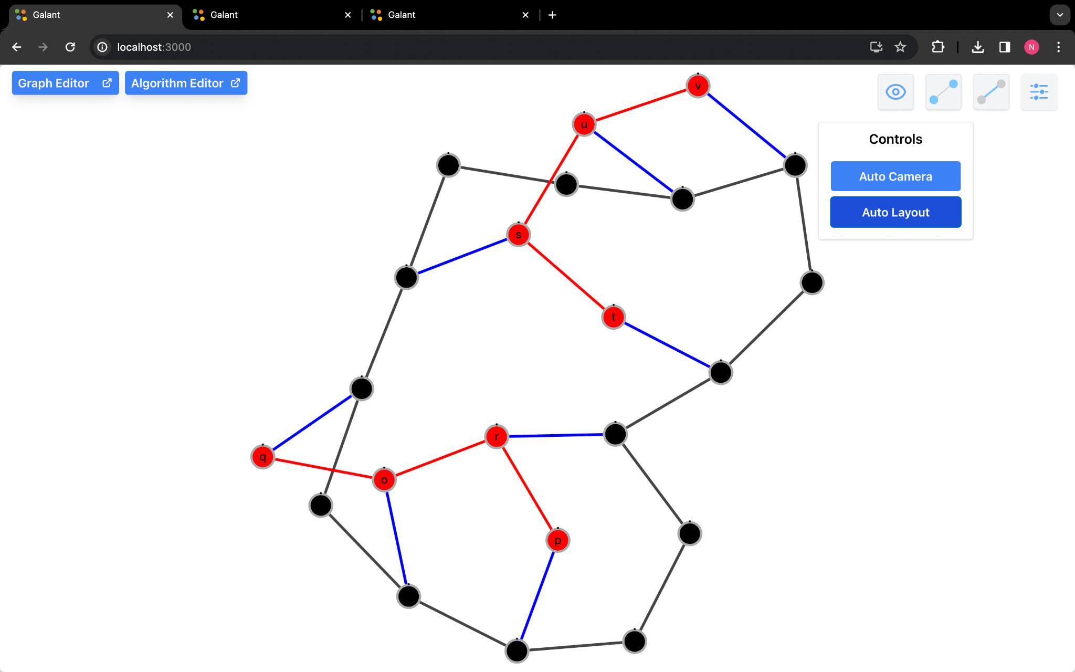

3. The user can access the node settings by pressing the n key or clicking on the line segment icon with the endpoints highlighted.



# 

# **Algorithm Methods**

## **List Getters**

These functions get lists of all nodes or edges in the graph to iterate over.

| **Function Name** | **Description** |
| --- | --- |
| getNodes() | Returns a list of all nodes in the graph. |
| getNumberOfNodes() | Returns the number of nodes in the graph. Can also use getNodes().length. |
| getEdges( | Returns a list of all edges in the graph to iterate over. |
| getNumberOfEdges() | Returns the number of nodes in the graph.  Can also use getEdges().length |

**Lists Example Algorithm**

//Prints each node and then each edge to the console.

for (let node of getNodes()) {

print(node);

}

for (let edge of getEdges()) {

print(edge);

}

## **Source and Target**

These functions select nodes or edges based on the source and target of edges.

Note that for undirected graphs, the source and target are interchangeable.

| **Function Name** | **Description** |
| --- | --- |
| source(edge) | Returns the source node of the specified edge. |
| target(edge) | Returns the target node of the specified edge. |
| getEdgeBetween(source, target) | Returns an edge between two nodes.  For directed graphs, only the edge in the direction specified will be returned.  If no edge exists between the specified nodes, returns null. |
| getEdgesBetween(source, target) | Returns a list of edges between two nodes. For directed graphs, only the edges in the direction specified will be returned.  This function is only needed if a graph contains multiple edges between the same nodes. |
| other(node, edge) | Returns the other node attached to the edge.  The node and edge parameters to this function may be provided in either order. |

**Source and Target Example Algorithm**

//This function returns the target of edge A B by finding the node opposite its source.

let edge = getEdgeBetween(“A”, “B”);

let source = source(edge);

print(other(source, edge));

## **Adjacencies**

These functions get lists of edges incident to a node to iterate over. In an undirected graph, all incoming and outgoing functions are equivalent to their non-directional counterparts.

| **Function Name** | **Description** |
| --- | --- |
| incident(node) | Returns all edges (incoming and outgoing) incident to a node. |
| incoming(node) | Returns all incoming edges of a node (the node is their target). |
| outgoing(node) | Returns all outgoing edges of a node (the node is their source). These functions get lists of nodes adjacent to a node to iterate over. |
| adjacentNodes(node) | Returns all nodes adjacent to the node. |
| incomingNodes(node) | Returns all nodes connected to the node by an incoming edge. |
| outgoingNodes(node) | Returns all nodes connected to the node by an outgoing edge.  These functions get the number of edges incident to a node. |
| degree(node) | Returns the number of edges incident to a node. |
| inDegree(node) | Returns the number of incoming edges of a node. |
| outDegree(node) | Returns the number of outgoing edges of a node. |

**Adjacencies Example Algorithm**

//This function prints each edge out of the node with the max number of outgoing edges.

let max = 0;

let maxNode = null;

for (let node of getNodes()) {

if (outDegree(node) > max) {

max = outDegree(node);

maxNode = node;

}

}

for (let edge of outgoing(maxNode)) {

let node = other(maxNode, edge);

print(edge);

print(node);

}

## 

## **Marks**

| **Function Name** | **Description** |
| --- | --- |
| mark(node) | Marks the specified node |
| unmark(node) | Unmarks the specified node |
| marked(node) | Returns true if the node is marked, false otherwise |
| clearNodeMarks() | Clears marks on all nodes |

**Marks Example Algorithm**

for (let node of getNodes()) {

mark(node);

}

## **Highlights**

| **Function Name** | **Description** |
| --- | --- |
| highlight(id) | Highlights the specified node or edge based on the id |
| unhighlight(id) | Unhighlights the specified node or edge based on the id |
| highlighted(id) | Returns true if the node or edge is highlighted, false otherwise |
| clearNodeHighlights() | Clears highlights on all nodes |

**Highlights Example Algorithm**

//Highlights all edges

for (let edge of getEdges()) {

highlight(edge);

}

## **Colors**

| **Function Name** | **Description** |
| --- | --- |
| color(id, color) | Colors the specified node or edge based on its id and given color |
| uncolor(id) | Uncolors the specified node or edge based on the id |
| getColor(id) | Returns true if the node or edge is colored, false otherwise |
| hasColor(id) | Returns true if the node or edge based on the id is colored |
| clearNodeColors() | Clears colors on all nodes |
| clearEdgeColors() | Clears colors on all edges |

**Colors Example Algorithm**

clearNodeColors()

## **Labels**

| **Function Name** | **Description** |
| --- | --- |
| label(id, label) | Labels the specified node or edge based on its id and given label |
| unlabel(id) | Unlabels the specified node or edge based on the id |
| getLabel(id) | Returns the labels of the specified node or edge based on its id |
| hasLabel(id) | Returns true if the node or edge has a label based on the id |
| clearNodeLabels() | Clears labels on all nodes |
| clearEdgeLabels() | Clears labels on all edges |

**Labels Example Algorithm**

//Un-labels each label of all edges (40 and 39 are weights on the edges, not labels)

for (let edge of getEdges()) {

unlabel(edge);

}

display(“Removed all edge labels”)

## **Weights**

| **Function Name** | **Description** |
| --- | --- |
| setWeight(id, weight) | Sets the weight of the specified node or edge based on its id and given weight |
| clearWeight(id) | Clears the weight of the node or edge based on the id |
| weight(id) | Returns the weight of the specified node or edge based on the id |
| hasWeight(id) | Returns true if the node or edge based on the id has a weight |
| clearNodeWeights() | Clears weights on all nodes |
| clearEdgeWeights() | Clears weights on all edges |

**Weights Example Algorithm**

//Sets the weight of each node to 10

for (let node of getNodes()) {

setWeight(node, 10);

}

## 

## **Hide/Show Node Properties**

| **Function Name** | **Description** |
| --- | --- |
| hideNode(node) | Hides the node based on the specified node id (also hides connecting edges to that node) |
| showNode(node) | Shows the node based on the specified node id |
| hideNodeWeight(node) | Hides the node weight based on the specified node id |
| hideAllNodeWeights() | Hides all node weights |
| showNodeWeight(node) | Shows the node weight based on the specified node id |
| showAllNodeWeights() | Shows all node weights |
| hideNodeLabel(node) | Hides the node label based on the specified node id |
| hideAllNodeLabels() | Hides all node labels |
| showNodeLabel(node) | Shows the node label based on the specified node id |
| showAllNodeLabels() | Shows all node labels |

**Node Properties Example Algorithm**

//Hides each node in the graph individually.

for (let node of getNodes()) {

hideNode(node);

}

display("Hid every node");

## 

## **Hide/Show Edge Properties**

| **Function Name** | **Description** |
| --- | --- |
| hideEdge(edge) | Hides the edge based on the specified edge id |
| showEdge(edge) | Shows the edge based on the specified edge id |
| hideEdgeWeight(edge) | Hides the edge weight based on the specified edge id |
| hideAllEdgeWeights() | Hides all edge weights |
| showEdgeWeight(edge) | Shows the edge weight based on the specified edge id |
| showAllEdgeWeights() | Shows all edge weights |
| hideEdgeLabel(edge) | Hides the edge label based on the specified edge id |
| hideAllEdgeLabels() | Hides all edge labels |
| showEdgeLabel(edge) | Shows the edge label based on the specified edge id |
| showAllEdgeLabels() | Shows all edge labels |

**Edge Properties Example Algorithm**

//Hides each edge weight in the graph individually.

for (let edge of getEdges()) {

hideEdgeWeight(edge);

}

display("Hid every edge weight");

## 

## **Node Shape**

| **Function Name** | **Description** |
| --- | --- |
| shape(id) | Returns the shape of the specified node based on the id |
| setShape(id, shape) | Sets the shape of the specified node based on its id and given weight |
| clearShape(id) | Clears the shape of the node based on the id |
| hasShape(id) | Returns true if the node based on the id has a shape |
| clearNodeShapes() | Clears shapes on all nodes |

**Node Shape Example Algorithm**

for (let nodeId of getNodes()) {

setShape(nodeId,”star”);

}

## **Node Border Width**

| **Function Name** | **Description** |
| --- | --- |
| borderWidth(id) | Returns the border width of the specified node based on the id |
| setBorderWidth(id, borderWidth) | Sets the border width of the specified node based on its id and given weight |
| clearBorderWidth(id) | Clears the border width of the node based on the id |
| hasBorderWidth(id) | Returns true if the node based on the id has a border width |
| clearNodeBorderWidth() | Clears border width on all nodes |

**Node Border Width Example Algorithm**

for (let nodeId of getNodes()) {

setShape(nodeId,5);

}

## **Node Shading**

| **Function Name** | **Description** |
| --- | --- |
| backgroundOpacity(id) | Returns the background opacity of the specified node based on the id |
| setBackgroundOpacity(id, backgroundOpacity) | Sets the background opacity of the specified node based on its id and given weight |
| clearBackgroundOpacity(id) | Clears the background opacity of the node based on the id |
| hasBackgroundOpacity(id) | Returns true if the node based on the id has a background opacity |
| clearNodeBackgroundOpacity() | Clears background opacity on all nodes |

**Node Shading Example Algorithm**

for (let nodeId of getNodes()) {

setShape(nodeId,0.5);

}

## 

## **Node Size**

| **Function Name** | **Description** |
| --- | --- |
| size(id) | Returns the size of the specified node based on the id |
| setSize(id, size) | Sets the size of the specified node based on its id and given weight |
| clearSize(id) | Clears the size of the node based on the id |
| hasSize(id) | Returns true if the node based on the id has a size |
| clearNodeSizes() | Clears size on all nodes |

**Node Size Example Algorithm**

for (let nodeId of getNodes()) {

setShape(nodeId,40);

}

## **Edge Width**

| **Function Name** | **Description** |
| --- | --- |
| edgeWidth(id) | Returns the edge width of the specified edge based on the id |
| setEdgeWidth(id, width) | Sets the edge width of the specified edge based on its id and given weight |
| clearEdgeWidth(id) | Clears the edge width of the edge based on the id |
| hasEdgeWidth(id) | Returns true if the edge based on the id has a edge width |
| clearNodeEdgeWidth() | Clears edge width on all edges |

**Edge Width Example Algorithm**

for (let edgeId of getEdges()) {

setShape(edgeId,10);

}